Aveiro Tech City Living Lab: A Communication,

Sensing, and Computing Platform for City Environments

Pedro Rito , *Member, IEEE*, Ana Almeida, Andreia Figueiredo , Christian Gomes , Pedro Teixeira , Rodrigo Rosmaninho, *Graduate Student Member, IEEE*, Rui Lopes , Duarte Dias, Gonçalo Vítor,

Gonçalo Perna, *Graduate Student Member, IEEE*, Miguel Silva, Carlos Senna , Duarte Raposo , Miguel Luís , Susana Sargento , Arnaldo Oliveira , *Member, IEEE*, and Nuno Borges de Carvalho , *Fellow, IEEE*

***Abstract*—This article presents the deployment and experimen- tation architecture of the Aveiro Tech City Living Lab (ATCLL) in Aveiro, Portugal. This platform comprises a large number of Internet of Things (IoT) devices with communication, sensing, and computing capabilities. The communication infrastructure, built on fiber and millimeter-wave (mmWave) links, integrates a communication network with radio terminals [WiFi, ITS-G5, cellular vehicular-to-everything, 5G and LoRa(WAN)], multipro- tocol, spread throughout 44 connected points of access in the city. Additionally, public transportation has also been equipped with communication and sensing units. All these points com- bine and interconnect a set of sensors, such as mobility (radars, light detection and rangings (LiDARs), and video cameras) and environmental sensors. Combining edge computing and cloud management to deploy the services and manage the platform, and a data platform to gather and process the data, the liv- ing lab supports a wide range of services and applications: IoT, intelligent transport systems (ITSs) and assisted driving, environmental monitoring, emergency and safety, and among oth- ers. This article describes the architecture, implementation, and deployment to make the overall platform to work and integrate researchers and citizens. Moreover, it showcases some examples of the performance metrics achieved in the city infrastructure, the data that can be collected, visualized, and used to build services and applications to the cities, and, finally, different use cases in the mobility and safety scenarios.**

***Index Terms*—Connectivity management, smart cities, software-defined networks, test-bed and trials, vehicular networks.**

Manuscript received 22 July 2022; revised 25 October 2022, 28 December

2022, and 31 January 2023; accepted 25 March 2023. Date of publication 28 March 2023; date of current version 25 July 2023. This work was supported in part by the European Regional Development Fund (ERDF), included in the “Urban Innovative Actions” Programme, through Project Aveiro STEAM City under Grant UIA03-084; in part by FCT/MEC through National Funds under Project PTDC/EEI-COM/5284/2020; and in part by the FCT/MCTES through National Funds and when applicable co-funded EU funds under Project UIDB/50008/2020-UIDP/50008/2020. *(Corresponding author: Pedro Rito.)*

Pedro Rito, Christian Gomes, Duarte Dias, Miguel Silva, Carlos Senna, and Duarte Raposo are with the Pólo de Aveiro, Instituto de Telecomunicações, 3810-193 Aveiro, Portugal (e-mail: pedrorito@av.it.pt).

Ana Almeida, Andreia Figueiredo, Pedro Teixeira, Rodrigo Rosmaninho, Rui Lopes, Gonçalo Vítor, Gonçalo Perna, Susana Sargento, Arnaldo Oliveira, and Nuno Borges de Carvalho are with the Departamento de Eletrónica, Telecomunicações e Informática, Universidade de Aveiro, 3810-193 Aveiro, Portugal, and also with the Pólo de Aveiro, Instituto de Telecomunicações, 3810-193 Aveiro, Portugal.

Miguel Luís is with the Pólo de Aveiro, Instituto de Telecomunicações, 3810-193 Aveiro, Portugal, and also with the Instituto Superior de Engenharia de Lisboa, Instituto Politécnico de Lisboa, 1959-007 Lisbon, Portugal.

Digital Object Identifier 10.1109/JIOT.2023.3262627

1. INTRODUCTION

HE CONCEPT of smart cities is not new [1]. In the last decade, several cities have gone through some form of digitization and sensing to analyse their behavior and the one of their citizens, and be able to actuate to processes that are not optimized, such as in the environment, health, and mobility areas. A key pillar in this process is the interconnection of the

**T**

several city elements.

Over the years there have been numerous research contribu- tions related to connectivity in different scenarios, including mobile scenarios with people, bicycles, and vehicles, but very few of them offer actual experimental results to sup- port their claims, even if at a small scale. The large majority of existing works still rely on numerical computations and computer simulations, not addressing the impairments of real environments.

The level of research that can be done in real environments can leverage the interaction with citizens and their services usability. On the one side, research can be tested in real envi- ronments with real users, making them a beneficial part of the research. On the another side, the applicability of the research can be tested and improved while it is being deployed and assessed in real environments.

In an urban living lab, multiple stakeholders (citizens, researchers, business, authorities, and city managers) form public-private people partnerships (4Ps) to solve problems, collaborate, cooperate, and innovate in a real-life context [2]. Urban living labs emerge with the increasing demand to solve urban issues, innovate, and make cities more inclusive. This is the purpose of our work: we have been deploying an advanced, large-scale communication, sensing, and computation infras- tructure, spread throughout the city of Aveiro in Portugal, that will be at the service of researchers, digital industries, startups, scale-ups, R&D centers, entrepreneurs, and other stakeholders interested in developing, testing or demonstrat- ing concepts, products or services, to solve the city-related problems.

This article presents the current deployment of the Aveiro Tech City Living Lab (ATCLL).1 It is supported by the state- of-the-art fiber link technology (spread across 16 km in the city), reconfigurable RUs, 5G-NR radio, and 5G network

1https://aveiro-living-lab.it.pt/

2327-4662 Ⓧc

2023 IEEE. Personal use is permitted, but republication/redistribution requires IEEE permission. See h[ttps://www.ieee.org/publications/rights/inde](http://www.ieee.org/publications/rights/index.html)x.html for more information.

services. The access infrastructure covers 44 strategic points in the urban area of Aveiro, in the form of Smart Lamp Posts or wall boxes on building facades with communica- tion technologies, edge-based computing units, and sensors. The communication infrastructure integrates a communication network with radio terminals, multiprotocol (5G, 4G, ITS-G5, WiFi, and LoRaWAN/LoRa), spread throughout the city, con- nected by fiber optics to a data processing center. Buses and garbage collection vehicles have also been equipped with com- munication units with WiFi, ITS-G5 and 5G technologies, and sensors, which currently record mobility and environmen- tal data, making a complete live map of these parameters in the city, and providing the required data for traffic mon- itoring and safe driving systems. All these points combine and interconnect a set of sensors, such as mobility sensors (GPS, traffic radars, light detection and ranging (LiDAR), and video cameras) and environmental sensors (such as tem- perature, humidity, and noise) with remote data collection units throughout the city, providing enough data to support a wide range of services and applications: from Internet of Things (IoT) and Internet access to citizens, to mobil- ity and assisted driving, intelligent transport systems (ITSs), environmental monitoring, emergency and safety, and among others.

This article describes the architecture, the technologies, and the mechanisms developed to make the overall platform to work and integrate researchers and citizens, testing mecha- nisms and providing services to the city. It also describes some examples of the performance metrics achieved in the city infrastructure, the data that can be collected, visualized, and used to build services and applications to the cities, and different use cases in the mobility and safety area that can be implemented and tested in the platform.

The remainder of this article is organized as follows. Section II contains the related work on living labs and deploy- ments throughout the world. Section III presents the proposed architecture of the living lab, detailing the technologies used in the network access, in the edge, in the sensing tasks, in the core, and solutions for third-party experimentation. This is followed by Section IV that describes the communication technologies in use, which includes sensing-to-infrastructure, vehicle-to-vehicle (V2V), vehicle-to-infrastructure (V2I), and people-to-vehicle, and presents the software-defined network (SDN) and named data network (NDN) communication paradigms available in our living lab. Section V contains the computing/edge approach, and the process to automate the deployment of services and applications, and Section VI details the ATCLL sensing capabilities. Section VII discusses the obtained results, and Section VIII presents several use cases. Finally, Section IX discusses the research challenges addressed during the implementation and operation of the ATCLL, and unfolds the discussion for open issues, and Section X enumerates the conclusions.

1. RELATED WORK

Throughout the years and around the world, the concept of a Smart City has been constantly evolving, not only in

hands with the technological advancements, but also regard- ing different services and applications offered to their citizens. While it is still a much more prominent deployed concept in Europe rather than in other continents, there is a trend on the evolution of smart cities leading to the creation of living labs within their sites. In this section, we present some of the related work and state-of-the-art on smart cities and some liv- ing labs implementations, in a trend starting at the year of 2010.

In the city of Oulu, Finland, Ojala [3] proposed an urban and open testbed with both WiFi and Bluetooth technologies and devices, to demonstrate the potential of such infrastructure. Its main goal was to study the utilization of pervasive com- puting services with technology pilots and service prototypes. Through the creation of an Open Ubiquitous City Challenge, several researchers created new applications through the WiFi and Bluetooth data, contributing to this urban testbed.

The SmartSantander project, starting also in 2010, is a city- scale experimental research facility in the city of Santander, Spain. The SmartSantander [4] monitors the environment by using low-cost sensors to measure the air quality, noise level, and luminosity level, and contains wireless technologies, such as IEEE 802.15.4 and cellular GPRS. The project also mon- itors the occupancy of some outdoor parking spaces using ferromagnetic wireless sensors, and provides parking status information to the citizens using display panels or mobile applications. SmartSantander contains a smart and automated irrigation system that sustainably manages the water consump- tion. It also provides context-sensitive information and services using augmented reality. The SmartSantander living lab con- tinued to grow over the years. The authors installed devices in 140 buses, taxis, and vans. With this information, they can assess environmental and traffic conditions [5]. This plat- form is addressing the sensing, but it is not ready to support latency-critical scenarios, such as automotive.

Roughly at the same time, Shenzhen, in China, was paving their own way into the design and further establishment of an IoT-enabled smart city architecture, strengthening its manufac- turing industry with the new digital industry, and managing their water quality parameters in real time. Moreover, this smart city implementation was also profitable in enhancing public safety through a large array of video cameras and IoT equipment (and controllers) covering the entire city, pro- viding the platform with anti-terrorism and crime prevention efforts [6]. This smart city project did not evolve onto a public living lab due to its strict policies and government-supported proprietary platform.

Traveling to other continent, and motivated by having strong necessities of safety, security, and disaster prevention, follow- ing landslide events in 2010, Rio de Janeiro, in Brazil, started in this year its smart city project in which they currently have installed 500 surveillance cameras and GPS sensors on all garbage trucks. Using a proprietary IoT platform using cel- lular network access technologies of both 3G and 4G, this deployment might not evolve into a living lab due to its smart city domain of governance.

With a different goal and exploring a different smart city application domain, the city of Masdar, in the United Arab

Emirates (UAE), started in 2011 a smart city project with a bottom-up approach, where the civil infrastructures were built following a sustainability agenda. Work still exists to exclusively allow autonomous vehicles in the city, solving most mobility issues of current urban scenarios. With such a goal still under development, the city has already imple- mented energy consumption measuring devices and techniques of energy harvesting [7], [8].

Still in the Asian continent, Singapore is the widest exam- ple of smart city currently set in the world. Also leading the Smart City Index in 2021,2 Singapore’s smart city architecture and platform is a national-level smart city with commercial services made available through it by the deployment of a large array of public WiFi access point (AP). Even being a government-led smart city, the Singaporean government enti- ties are actively driving public actors to use smart city data in order to help to solve urban issues. This initiative made possible to create 120 living labs in the city [9]. The current communication is, however, concentrated on the WiFi-based technologies.

In the United States of America, in 2015, work was done again to improve mobility, public safety, and also to help fostering economic growth in Atlanta. With the design and further implementation of the smart city concept in the city of Atlanta, 200 sets of IoT nodes were deployed in the city area, along with cameras for surveillance. This infrastructure allowed technological enterprises, such as Intel and General Electric, to develop a proper platform and create services, such as bike sharing or vehicle smart corridors (for mobility pur- poses), safety alerts, or smart trash bins [9]. A Web platform was made available3 in which a living lab is presented.

The City of Things, a smart city testbed established in Antwerp, Belgium [10], was presented in 2016. The City of Things allowed the researchers to perform experiments on large-scale multitechnology IoT networks, data, and in the liv- ing lab. The technologies deployed are IEEE 802.1ac on 2.4 and 5 GHz, DASH7 on 433 and 868 MHz, Bluetooth (Low Energy), IEEE 802.15.4, IEEE 802.15.4g, and LoRa. With this platform, they were able to monitor air quality, traffic, parking spot occupancy, and manage smart parking signs.

There are also several IoT sensing testbeds that focus more on the IoT architecture and services, with base wireless tech- nologies, such as WiFi, Bluetooth, LoRa or cellular, and environment sensing. Examples emerge from Mexico [11] for environment, water, and energy; from university campuses as living labs for energy management, such as in Brazil [12]; from Antwerp [13] for air quality measurement, traffic mon- itoring through traffic counter sensors and smart parking. Dublin also contains a platform4 on a business perspective, that addresses several areas, such as environment and mobility. Moreover, Amsterdam is one of the oldest IoT-enabled smart city platforms created in which, without having any IoT platform interconnecting all the nodes simultaneously, it allows users in a living lab open space to use LoRa and

2[https://www](http://www.imd.org/smart-city-observatory/home).imd.org[/smart-city-observatory/home](http://www.imd.org/smart-city-observatory/home) 3https://docs.cityiq.io

4https://smartdublin.ie/

Bluetooth resources made available throughout the city (in a network with 46 gateways) [9]. Such infrastructure allowed citizens (as it is a citizen-centered project) to create fea- tures and services, such as car pooling and smart parking. This infrastructure is a result of a partnership with more than 600 organizations in the Amsterdam Smart City project.5

A platform in [14] presents a real-world testbed for research and development in vehicular networking that has been deployed successfully in the seaport of Leixões, Portugal. The testbed allows cloud-based code deployment and, through the ITS-G5 technology, it allows remote network control and dis- tributed data collection from moving container trucks, cranes, tow boats, patrol vessels, and roadside units, thereby enabling a wide range of experiments and performance analyses.

In Busan, South Korea, one can also find a smart city with living labs for energy, factory, logistics, healthcare, urban regeneration, and transportation [9]. Using oneM2M as the standard for the IoT interconnection between all the nodes in this smart city network, the infrastructure allows services to take profit of both cellular (3G to 5G) and LoRa connections [15].

Following the work of Sotres et al. [15], the authors explore a smart parking use case scenario in which they gather data from a global IoT service proposed by them to provide parking guidance and mobility suggestions in the smart cities of Busan, Seoul, and Seongnam in South Korea, and Santander and Barcelona, in Spain. Barcelona, which is also home to a smart city project [16], has one of the largest amount of data sources available in a living data source environment, whose access is public.6 Barcelona has a great effort in partnering with network operators for 5G-based projects, but does not own a complete road-side unit (RSU) infrastructure, multitechnology, deployed only to the city use cases.

PortoLivingLab [17] is a smart city testbed located in the city of Porto, Portugal. Through the deployment of several sensors installed in city buses and other static locations, it can collect, through ITS-G5 or LTE, data about the environment (noise and air pollution), weather, public transport, and peo- ple’s flows. This originated three monitoring platforms with sensing capabilities and a common backend infrastructure. The first monitoring platform is a crowdsensing research tool that collects data from participants’ smartphones through WiFi and cellular. The second one allows monitoring the environment through WiFi. The last one contains a network of buses, each one equipped with an on-board unit (OBU) in order to achieve V2V and V2I communication.

PASMO [18] is a highway ITS road between the seaside and Aveiro/Ílhavo, in Portugal, providing vehicular communi- cations through ITS-G5. This road enables the test of vehicular communications and road automotive use cases. The living lab presented in this article, in the city of Aveiro, inte- grates with PASMO in the highway. In a similar strategy, the Smart Highway testbed [19] was built on a highway close to Antwerp, connecting it to the IMEC Smart Cities initiative to

5https://amsterdamsmartcity.com

6https://opendata-ajuntament.barcelona.cat/en/

provide a mixed environment for testing various V2X com- munication protocols and autonomous car functionalities [20], and part of the federation of testbeds initiative Fed4FIRE .7 On the 5G perspective, l’Aquila in Italy has been proposed as a living lab for 5G experimentation [21], but only the fiber optical ring has been presented, as well as use cases to be tested. Bristol in U.K. has also a testbed that is being used on a business perspective,8 which encompasses some technologies,

+

such as 5G in specific places.

On a different perspective, living labs for autonomous driv- ing have also been deployed. The work in [22] presents the Autonomous Vehicles—AV Living Lab that spreads across the shopping center BTC in Ljubljana, Slovenia, with autonomous vehicle demonstration events.

More recently, in 2021, in New York City, United States of America, a testbed was implemented to study highly time- dependable interactions between urban actors in one of the busiest metropolises in the world. Deployed in a busy urban traffic intersection, the COSMOS Experimental Testbed [23] includes a set of cameras and edge computing nodes in order to sense vehicles and pedestrians moving in many directions at various speeds, often with chaotic or unpredictable behaviors. Despite solely focusing on an intersection, whilst some researchers attempt to enhance their capabilities and behav- ioral models for sensing different data and strengthen some provided services, other members of the scientific commu- nity allow, in an open living lab concept, to create and to experiment new services in preknown IoT environments. Amaxilatis et al. [24], as well as Gutiérrez et al. [25], have proposed the concept of experimentation-as-a-service in the European project OrganiCity.9 Over the course of three years,

OrganiCity supported 43 experiments, successfully addressing urban challenges in cities around the world.

Our approach in this living testbed goes beyond these several examples in providing simultaneously the following aspects.

1. The ATCLL encompasses different communica- tion technologies for people, sensors, and vehicles, simultaneously.
2. It includes different sensors, in a fusion approach, addressing the monitoring with different perspectives and higher accuracy.
3. It encompasses both access, edge, and core infrastruc- ture, and both network and data management.
4. It is programmable and with third-party seamless inte- gration.
5. It addresses different use case scenarios, from data gath- ering to real-time actuation, from the environment to mobility and self-driving.
6. AVEIRO TECH CITY LIVING LAB ARCHITECTURE

ATCLL has been designed with the following three main objectives.

7[https://www.fed4fire.eu/](http://www.fed4fire.eu/)

8[https://www.bristol.go](http://www.bristol.gov.uk/)v.uk/ 9https://organicity.eu

1. To build a communication, sensing, and computing infrastructure connected by fiber optics integrating a communication multiprotocol network with radio termi- nals for short, medium, and long-range communication.
2. To implement a sensing platform capable of under- standing the environment quality and citizens’ behavior within the city, and providing new solutions toward efficient traffic management, ITSs and citizens’ safety.
3. To provide an open platform for third-party partners to test their own protocols, mechanisms, prototypes, or explore collected data to build new services and applications.

This platform has been built through an Urban Innovative Action “Aveiro STEAM City,”10 coordinated by the Municipality of Aveiro, and with partners, such as Altice Labs, University of Aveiro, and Instituto de Telecommunicações. This project started in October 2018 with 3.5 years dura- tion. The platform is being managed by Instituto de Telecommunicações, and is sustained through partnerships with companies to develop their use cases and projects, and research projects from national and international funds.

The structure of the platform can be divided in the following manner.

1. Access and edge, which is supported on fiber technology and millimeter-wave (mmWave) links, edge computing, high data-rate SDN devices and RUs, either dedicated or software-defined radio (SDR) based.
2. Sensing devices and platform, static and mobile, collect- ing various forms of data.
3. Backhaul and core, which consists of the datacenter with core network devices and servers to manage the network.
4. Backend and data platform, which are composed of the data platform with data brokers, data persistence, and data processing.

The SDN architecture separates the control and management planes from the data plane, simplifying the manageability and programming of the network, adding to the ATCLL infrastruc- ture concepts of programmable and active networks, which meet the complexity expected for the new generation of applications and network services [26].

Fig. 1 depicts the ATCLL in the map of Aveiro, its fiber connections and the different APs placed in strategic loca- tions in the city. Fig. 2 illustrates the high-level diagram of the infrastructure, architecture, and services of the ATCLL. The next sections describe the several components of the ATCLL architecture.

1. *Access and Edge*

The access infrastructure is based on the single-mode optical fiber (SMF) link technology (G.652), with 16 km of length, interconnecting the edge nodes with reconfigurable RUs and 5G network services, in 44 strategic places covering the urban area of Aveiro. These points are deployed in the form of Smart Lamp Posts or wall boxes on building facades. Examples of Smart Lamp Posts and wall boxes are depicted in Fig. 3.

10[https://www](http://www.aveirotechcity.pt/pt/projetos/AVEIRO-STEAM-CITY).av[eirotechcity.pt/pt/projetos/](http://www.aveirotechcity.pt/pt/projetos/AVEIRO-STEAM-CITY)AVEIR[O-STEAM-CITY](http://www.aveirotechcity.pt/pt/projetos/AVEIRO-STEAM-CITY)

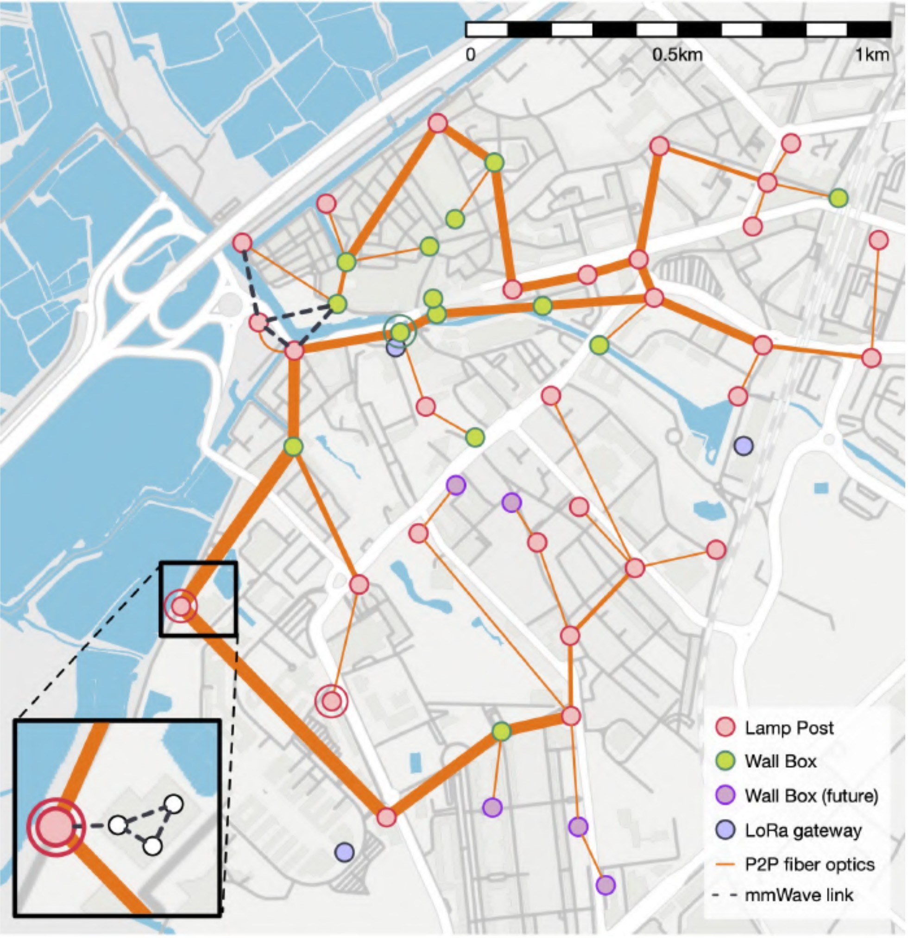

Fig. 1. ATCLL map in Aveiro. Thicker optical connections represent cables with 96 or 144 fibers, and thinner connections represent cables typically with 12 fibers.

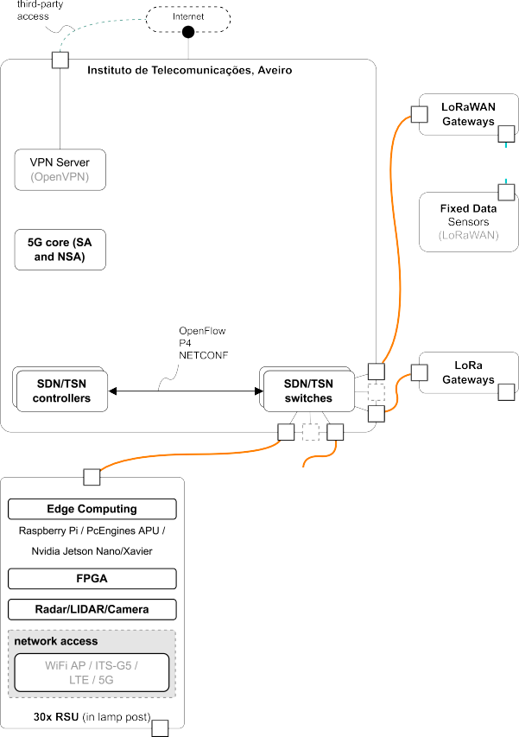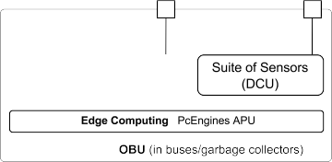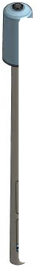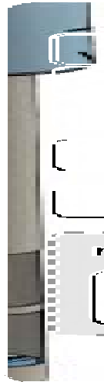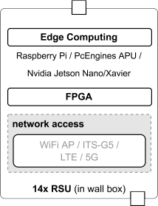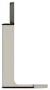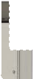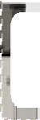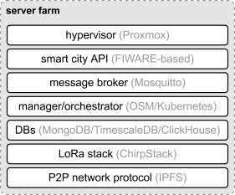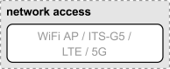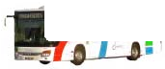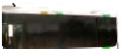

The physical infrastructure of the access network is composed of one-to-one fiber links aggregated by the Edge-Core 5812-54X switch, with Pica8 PicOS,11 support- ing 10-GbE connections, and SDN functionality through Open vSwitch (OVS).12 The uplink to the core is completed with 40 GbE ports, connecting to core switches such as the Edge-Core Wedge100BF-32X, supporting P413 with the pro- grammable Tofino switch silicon.14 Supporting SDN allows the control of the network by software, using open-source controllers, such as Ryu15 and ONOS,16 and control plane pro- tocols OpenFlow and P4 Runtime. In addition, time-sensitive network (TSN)17 features are available in several devices of the access infrastructure, configured by NETCONF. Finally, network algorithms and machine learning techniques are also included to monitor and take action in the network. For instance, in the case of the mobility network, Internet connec- tivity, and handovers in the mobile nodes are made possible by the algorithms running through the SDN controller [27] (more details in Section IV-E).

Regarding the edge points, they combine different equip- ment for several purposes in each Smart Lamp Post/wall box, mainly communication APs, and multiaccess edge computing (MEC). In terms of communication technologies, there are two main devices providing wireless access: 1) FPGA-based SDR units, with a wideband (300 to 6 GHz) integrated radio

11[https://www.pica8.com/picos-softw](http://www.pica8.com/picos-software/)are/

12[https://www](http://www.openvswitch.org/).openv[switch.or](http://www.openvswitch.org/)g/

13https://opennetworking.org/p4/

14[https://www.intel.com/content/www/us/en/products/netw](http://www.intel.com/content/www/us/en/products/network-)ork- io/programmable-ethernet-switch/tofino-series.html

15https://ryu-sdn.org/

16https://opennetworking.org/onos/

17https://1.ieee802.org/tsn/

Fig. 2. ATCLL architecture.

frequency (RF) frontend, to provide cellular access (4G, 5G and beyond) and 2) a PC Engines APU.18 Regarding MEC, every point has available a set of Nvidia Jetson Nano or Jetson Xavier with a powerful GPU for graphic-intensive processing, and a Raspberry Pi 4 aimed for the deployment of lightweight services.

1. *Sensing*

The ATCLL contains static sensors in the edge nodes of the infrastructure, such as spectral probes, traffic radars, LiDARs, and video cameras (as seen in Fig. 3). Information com- ing from these devices is aggregated and correlated to give insights on the people’s flow, providing concrete elements for new solutions on public transportation, safety-critical, and autonomous driving systems, and to identify problems and optimize the mobility in the city. The spectral probe is a pas- sive radar system consisting of an antenna array comprising

18[https://www.pcengines.ch/apu2.htm](http://www.pcengines.ch/apu2.htm)

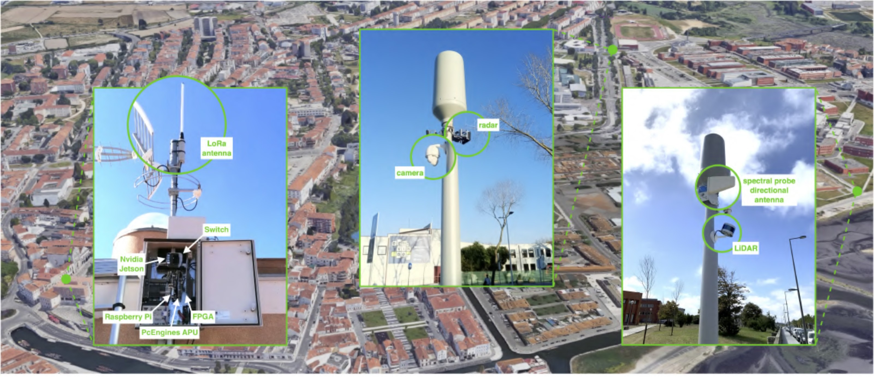

Fig. 3. Wall box and Smart Lamp Post examples.

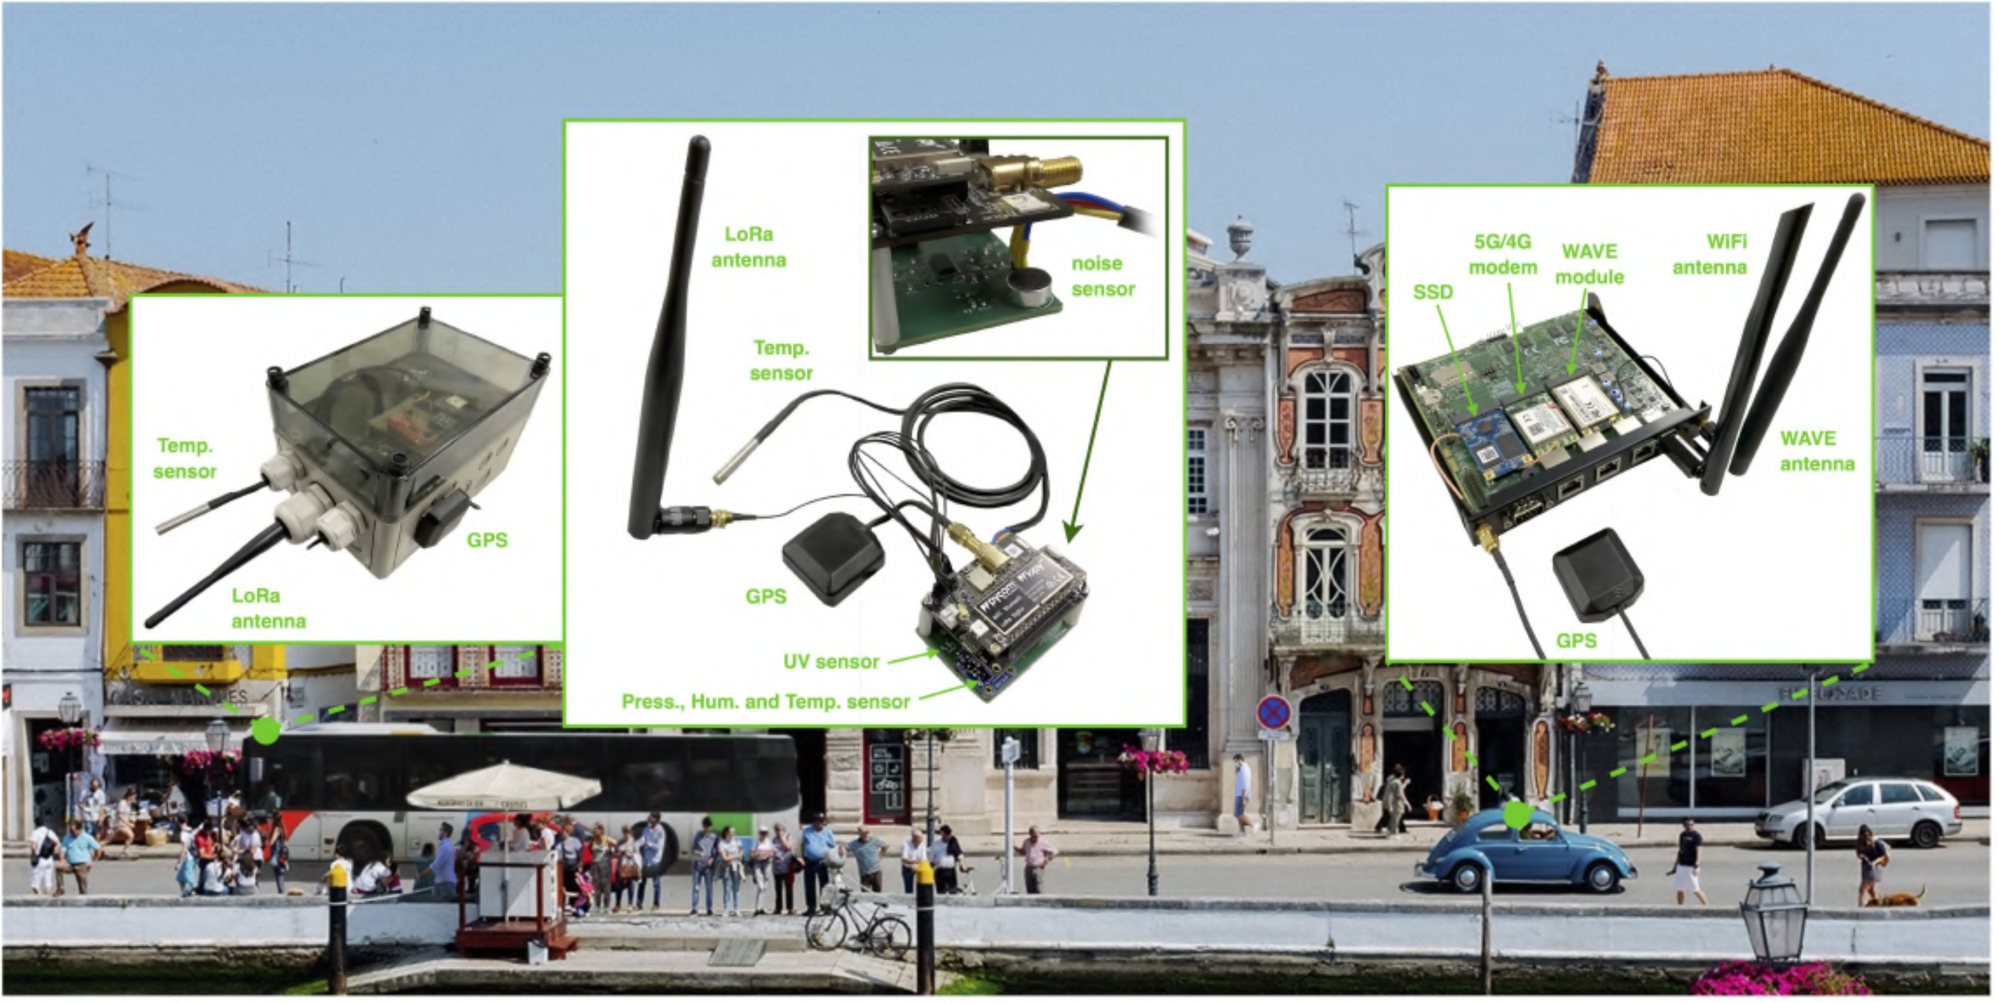

Fig. 4. DCUs and OBUs.

three dipoles forming a 360◦ antenna and a low-cost commer- cial SDR (ADALM-PLUTO)19 connected to the Raspberry Pi

for processing the collected data. The FPGA-based SDR units can also be individually reconfigured to implement wideband, high-performance, and real-time distributed spectral probes, with centralized processing of the acquired signals that can be stored and used as rich data sets for different purposes. The other static sensors are described in more detail in Section VI-A.

The ATCLL also contains mobile sensing devices and other geolocation sensors installed on vehicles (buses and garbage collection vehicles) and local boats (*moliceiros*). The available mobile sensing information comprises GPS location, speed and heading, temperature, humidity, and air pressure, which enables the complete mobility map of the city. Communication equipment is also installed in the vehicles and local boats to transmit mobility and environment data through the static APs, making a complete live map of these parameters in the city, and providing the required data for environment sensing, traffic

19[https://www.analog.com/en/design-center/e](http://www.analog.com/en/design-center/evaluation-hardware-and-)v[aluation-hardw](http://www.analog.com/en/design-center/evaluation-hardware-and-)a[re-and-](http://www.analog.com/en/design-center/evaluation-hardware-and-) software/evaluation-boards-kits/adalm-pluto.html

monitoring, and safe driving systems. The mobile equipment is composed of a data-collection unit (DCU) (Fig. 4) which integrates WiFi and LoRa communication. The vehicles also include an OBU (Fig. 4) with WiFi, ITS-G5, and cellular com- munication to establish the connection with the RSU and with other vehicles. Currently, 15 public buses are working as con- nected vehicles with OBUs, and an extension up to 30 buses is being performed. Cars with integrated OBUs from the start (such as modern Volkswagen cars) are also detected and com- municate with our RSU. A set of unmanned aerial vehicles (UAVs) equipped with video cameras and sensors are also considered as mobile sensing units to gather data from the city and to give support to patrolling and traffic management. The WiFi APs, both in the static APs and in mobile on board units in the vehicles, are also gathering data from people’s smartphones through their connectivity in the city.

1. *Core and Data Platform*

The infrastructure is complemented with a network and data processing center located at the premises of Instituto de Telecommunicações. The datacenter is composed of multiple

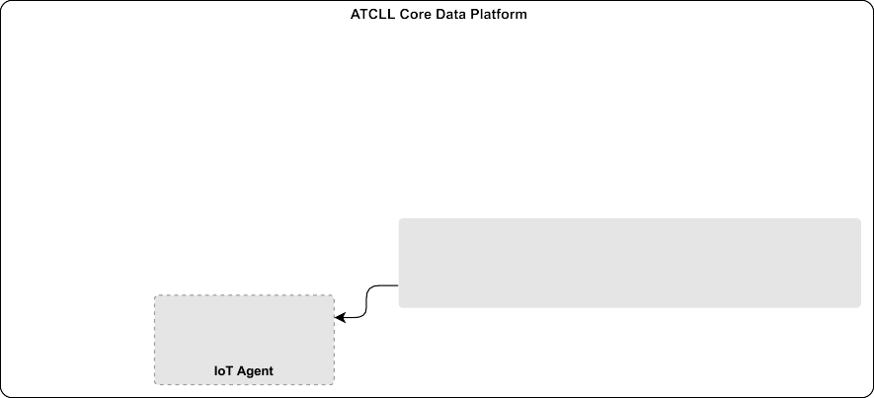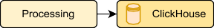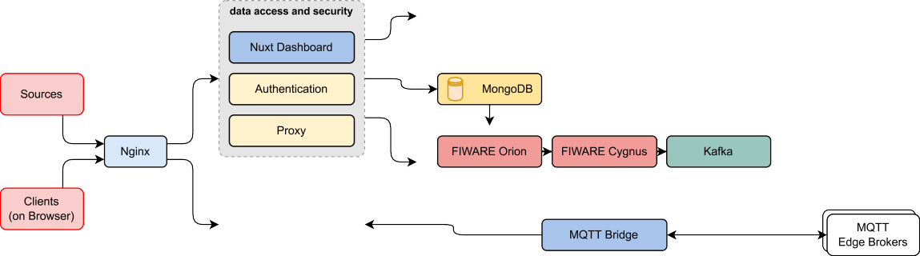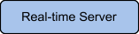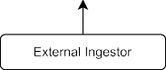

Fig. 5. ATCLL data platform diagram.

servers, which deploy all virtual machines with the services, data platform, apps, 5G core, orchestration, and network func- tions running in the cloud, such as Kubernetes,20 OSM,21 ChirpStack,22 and among others. The SDN controllers are also deployed in the core of the network, defining the structure of access and mobility networks, and reacting dynamically to possible changes in the demand and conditions of the network. Regarding the infrastructuring monitoring, all new communi- cations received from mobile or static sensors are registered in a centralized monitoring and alerting platform (Zabbix23 and Grafana)24 allowing the examination of the health status (time since last seen) of a given end-device and, therefore, of the system as a whole at any given time.

The management of the data collected through the ATCLL sensing devices is performed by the *Core Data Platform* [28], as depicted in Fig. 5. This platform is capable of receiv- ing, storing, and processing information from several different domains, while exposing it in a secure and efficient manner via various different interfaces. The platform was designed on top of the multitenant model of FIWARE’s Orion Context Broker,25 the core of the real-time transport module and the PoA of the ATCLL platform. This broker follows a publisher- subscriber model that allows the creation and update of entities and subscriptions, logically separated by the value present at the FIWARE-Service header of the requests. The data platform extends this model and also uses the FIWARE- Service header to perform authentication, persistence, and access to the information separated by tenants/domains. The Orion Broker also supports hierarchical scopes, with the FIWARE-ServicePath header, that can be freely used with the Orion instance to divide entities and subscriptions of a FIWARE-Service by different paths. On the entrance of the platform, there is an Nginx26 instance working as a reverse

20https://kubernetes.io/

21https://osm.etsi.org/

22[https://www.chirpstack.io/](http://www.chirpstack.io/)

23[https://www.zabbix.com/](http://www.zabbix.com/)

24https://grafana.com/

25https://fiware-orion.readthedocs.io/en/master/

26[https://www.nginx.com](http://www.nginx.com/)

proxy while also managing the SSL certificates, offloading the deciphering process from the servers.

The main services used to manage and persist the data are the *Processing* service and the ClickHouse27 database. The *Processing* service is responsible for a preliminary processing before the data reaches Orion, more specifically finding the road segment of each received point and converting the objects following the FIWARE NGSI-LD model,28 and then persisting the data on the respective table, depending on the FIWARE- Service attribute and on the data type. For the persistence of the data collected through the sensors and communication devices in the infrastructure, the ATCLL includes a database management system (DBMS), ClickHouse. This database has native compression capabilities that can greatly decrease the databases’ size, while speeding up the analytical queries.

In order to gather the data from all the city points, we use two additional brokers on the platform. First, we use a mes- sage queue telemetry transport (MQTT) broker that serves as a bridge to all the edge devices, making available all the edge sensing data in the core, allowing central computing and cloud data persistence. The other one is Kafka29 that distributes all the real-time data inside the core network. All services inside the core network that need to consume the data use this Kafka broker in order to lighten the MQTT and Orion loads.

1. *Third-Party Access and Federation*

The ATCLL includes different means of allowing third-party access. In terms of data sharing, the Orion Context Broker is exposed publicly. It allows both the reception of data into the platform, and also the distribution to the consumers in real time. Using a token-based security layer on top of the broker, managed by the *Authentication* service, the information is kept on the platform as consistent as possible, while only giving access to authorized entities. Additionally, the *Processing* ser- vice has available several public APIs intended to make the

27https://clickhouse.com/

28[www.fiware-datamodels.readthedocs.io/en/latest/ngsi-ld-howto](http://www.fiware-datamodels.readthedocs.io/en/latest/ngsi-ld-howto)

29https://kafka.apache.org/

data available for the dashboard, as well as a historical API,30 secured by the token authentication method, that can be used to obtain persisted data from any service and type of any time interval.

The ATCLL also allows direct access to the network and computing devices, and to the sensors.31 This feature is highly flexible, with the possibility to give access to experimenters through VPN solutions, such as OpenVPN,32 Wireguard,33 and Tailscale.34 Finally, the ATCLL is federated through the Fed4FIRE 35 initiative, one of the largest federations of Next Generation Internet testbeds enabling the experimentation by several actors from researchers up to SMEs and large com- panies. Being federated, the access can be performed using the jFed36 experimentation toolkit that allows experimenters to push their code to the nodes and to use a graphical user interface with real-time information of the experiment execution.

+

1. COMMUNICATION APPROACH

One of the main novelties of this platform is its multitechnology capability. This platform supports various types of communication, covering short-, medium-, and long- range wireless communications. This section details the com- munication approach between the mobile and static elements, how the mobile and sensing nodes are able to be seamlessly connected between themselves and to the infrastructure, and the motivation behind the selection of the various means of technologies.

1. *Communication Technologies*

To support short-range wireless communications to vehicles and pedestrians, we focused on supporting two main technolo- gies: 1) ITS-G5 and 2) WiFi. In all 44 city nodes represented in Fig. 1 we installed RSU with the ITS-G5 technology (based on IEEE 802.11p), designed to be operated in urban envi- ronments, and WiFi APs. Additionally, two nodes contain also cellular vehicular-to-everything (C-V2X). The RSU and OBUs are implemented using a single-board computer (SBC) produced by PC Engines. We use the same SBC for the WiFi AP.

In terms of medium-range communication, apart from the deployment of the OBUs (with cellular modems) as user equipments (UEs), the infrastructure includes radio access network (RAN) deployments, where the radio units (RUs) or small cells are placed inside the Smart Lamp Posts and the wall boxes on building facades. The main RAN deployment is a 5G O-RAN demonstrator with 20 RUs built on FPGA-based SDR boards. This distributed topology of RUs takes advan- tage of the fiber network linking the city nodes to the core for the fronthaul communication. Other nodes include small

+

30https://aveiro-living-lab.it.pt/docs/

31[https://www](http://www.aveirotechcity.pt/en/activities/aveiro-tech-city-living-lab).av[eirotechcity.pt/en/activities/a](http://www.aveirotechcity.pt/en/activities/aveiro-tech-city-living-lab)v[eiro-tech-city-li](http://www.aveirotechcity.pt/en/activities/aveiro-tech-city-living-lab)v[ing-lab](http://www.aveirotechcity.pt/en/activities/aveiro-tech-city-living-lab)

32https://openvpn.net/

33[https://www](http://www.wireguard.com/).wire[guard.com/](http://www.wireguard.com/)

34https://tailscale.com/

35[https://www.fed4fire.eu/ne](http://www.fed4fire.eu/news/new-testbeds-joins-the-fed4fire-federation/)ws/new[-testbeds-joins-the-fed4fire-federation/](http://www.fed4fire.eu/news/new-testbeds-joins-the-fed4fire-federation/)

36https://jfed.ilabt.imec.be

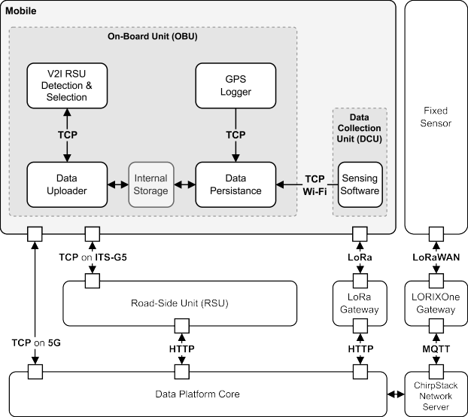

Fig. 6. Sensing to infrastructure communication architecture.

cells of third-party vendors. With both approaches, the ATCLL offers the possibility to have private 5G network deployments for testing and development of use cases requiring cellular access. Moreover, with the integration of SDR hardware, the infrastructure is also evolving into a testbed of beyond-5G and 6G technologies.

Finally, regarding long-range communication, the infrastruc- ture supports LoRa communication using a custom protocol and LoRaWAN protocol, both in the end devices (data- collection unit) and in the gateways. The LoRa with custom protocol implementation hardware consists, in DCUs and gate- ways, of a Raspberry Pi model 3B SBC with a multiprotocol radio shield that attaches a Libelium SX1272 module and an 868MHz antenna. To maximize the range while maintaining a sensible data rate, the SX1272 module is used in mode 3, which entails a spreading factor of 10 and a coding rate of 4*/*5. For the LoRaWAN protocol, the DCUs are based on LoPy437 (Fig. 4), and the gateways are LORIX One38 or an extension to the APU board with an mPCIe card. End devices join the network via over-the-air activation (OTAA) and transmit, in most cases, using a spreading factor of 9 and a coding rate of 4*/*5. At the time of writing of this article, there are two LORIX One outdoor gateways placed in strategic locations in the city (Fig. 3), with more gateways to be deployed in the near future.

+

1. *Sensing to Infrastructure Communication*

Data generated from the various sensing modules is acquired using different technologies depending on the data source (Fig. 6). Sensing data from the DCU with low periodicity and nonreal-time requirements is sent over LoRa or LoRaWAN, due to their duty-cycle requirements; high-periodic data is sent through WiFi (relayed through ITS-G5 or 5G); and real-time

37https://pycom.io/product/lopy4/

38[https://www.lorixone.io/](http://www.lorixone.io/)

data originated from the OBU, such as GPS and mobil- ity detection information, are sent directly through ITS-G5 and 5G.

The LoRa transmissions include the latest measurement information encoded in a custom payload, and occur approxi- mately every 2 min and 20 s, so as to comply with duty cycle restrictions referring to the use of LoRa frequency bands in the EU. This approach introduces a degree of communica- tion redundancy, and is especially useful to collect up-to-date data in routes with low ITS-G5 coverage, and in deployments where the DCU is the only equipment installed in the vehicles (this is the case of garbage collection vehicles in the city). Once received by a gateway, LoRa frames are decoded and sent to the data platform in the form of NGSI-LD objects, as previously described. For the sensors using LoRaWAN, the end devices join the network via OTAA, and communications (both uplink and downlink) are managed by the ChirpStack39 Open-Source LoRaWAN Network Server Stack hosted in the ATCLL core. Uplink frames are provided via the HTTP inte- gration to a NodeJS microservice that forwards them to the cloud, which decodes them and returns the measurements for inclusion in the data platform. Downlink payloads are received by another NodeJS microservice that performs the necessary Network Server API interactions to enqueue them.

The data originating from DCU equipment installed on the vehicles can also be sent to the OBU via a wireless WiFi network through an open TCP socket. The information is then persisted in a last in first out (LIFO) queue kept on the filesys- tem,40 which aggregates all the data points produced by the different sensors and services active on the bus. Keeping the queue in the filesystem preserves it in the event the bus powers off before communication with the infrastructure is possible. V2I micro services present in the V2I network are continu- ously polled until a suitable known RSU is detected within range, at which point the data queue is compressed, encrypted with pretty good privacy (PGP), and sent via TCP through the ITS-G5 or 5G interface. It is then deleted from the OBU upon acknowledgment of successful integrity verification at the des- tination (MD5 hashsum). Once in the RSU, the elements in the queue are processed by a multithreaded pool of consumers that decode the information and, when applicable, build a standard FIWARE NGSI-LD JSON payload that is then sent to the data platform. This software stack supports the collection of sev- eral types of data, from multiple sources, and at any desired measurement frequency, thus allowing for future integration with other sensors and different use cases.

1. *Vehicle-to-Vehicle and Vehicle-to-Infrastructure*

Due to the need for very low delays and medium-range communication, the technologies used for V2V and V2I communication are ITS-G5 (and C-V2X) and 4G/5G. The SBCs selected for the OBUs are equipped with an IEEE 802.11a/b/g/n mini-PCIe wireless card, used for the ITS-G5 communications, through a patch to the Linux kernel, to per- mit operating in the desired 5.9-GHz band and including

39[www.chirpstack.io](http://www.chirpstack.io/)

40https://pypi.org/project/persist-queue/

the OCB mode support41 (meaning *outside the context of a BSS*) to the ath9k driver. The OBU also contains an LTE CAT-1 mini-PCIe module or 5G *m.2* module and an exter- nal USB dual-band wireless adapter (Fig. 4). The cellular modem is used both for cellular connectivity and GPS loca- tion, since the GNSS technology is included in this module. For the 5G module to work properly, the ModemManager from *freedesktop.org*42 was used. This module supports nonstan- dalone (NSA) and standalone (SA) operation modes depending on additional configurations. The cellular link allows to have connectivity in the surroundings of the city and in noncovered urban areas with the RSU’ ITS-G5 connection.

To have information about the surroundings of each node and current network topology, both OBUs and RSU need to announce themselves in the correct frequency channel. This announcement is made with cooperative awareness mes- sages (CAMs) sent in broadcast to every neighboring station. These messages are periodic and contain information related to the position, speed, heading, and status of the sender entity. When an application detects relevant traffic events (e.g., acci- dents, dangerous end of the queue, and emergency vehicle approaching), it can send decentralized environmental notifi- cation messages (DENMs). The event can be characterized by an event type, a position, a detection time, and a time duration. The main goal of DENM transmission is to alert road users about that event. The creation of these messages is performed in layer 2 and is done using a GeoNetworking library [29] that also includes an ASN.1 UPER encoder. An additional link-layer entity was developed, transforming sim- ple messages (UDP) to standardized messages (ITS-G5), and performing also the opposite message transformation.

In order to provide Internet to the users inside the vehicles, the OBU contains an external wireless adapter, serving as an AP for passengers inside the vehicle and for the DCU that sends all the gathered data via WiFi to the OBU. A VANET connection manager (VCM) is responsible for choosing in real-time the best ITS-G5 Point of Access (PoA) to assure IP connectivity between the OBU and the infrastructure. Thus, it needs to determine if there is any ITS-G5 PoA available to decide if it should be used or a cellular technology instead (4G or 5G). In the case of one or multiple ITS-G5 PoAs in its communication range, it needs to determine which one should be used.

The VCM algorithm present in ATCLL OBUs is an evolu- tion from the previous work in [30]. It establishes a connection to the PoA that presents the best received signal strength indi- cation (RSSI), and settles some thresholds to determine when it should consider changing to another PoA with a better RSSI level or not. The decision also considers the GPS position and heading from the vehicle. This avoids connecting to an RSU that, besides having the best RSSI currently, is located on the other side of the road, so the RSSI would decrease rapidly while driving in the opposite direction. In addition, the VCM is capable of changing between an ITS-G5 and 5G connec- tion when there are no RSU in the surroundings of the vehicle.

41https://ctu-iig.github.io/802.11p-linux/

42[https://www.freedesktop.org/wiki/Software/ModemManager/](http://www.freedesktop.org/wiki/Software/ModemManager/)

Current work addresses the improvement of this mechanism, considering other metrics and SDN capabilities in the network (Section IV-E).

1. *People-to-Infrastructure*

People-to-people (P2P) and people-to-infrastructure (P2I) communication is performed using a smartphone support- ing communication technologies, such as WiFi or cellular technologies, including LTE and 5G. The choice of the smart- phone is motivated by its ubiquity, high programmability, and reduced cost compared to other solutions. The choice of technologies are, therefore, inherent to the ones available in the smartphone. We developed an additional application to allow the vulnerable road users (VRUs) to communicate with the infrastructure, making it possible for VRUs to commu- nicate information about them and receive notifications from the infrastructure about potentially dangerous situations (e.g., potential crashes).

The information obtained from the station allows the announcement of the necessary awareness information about VRU: location, altitude, heading, and speed, but also ori- entation, direction, size and weight class, and VRU profile. To obtain this information set, the information from the smartphone from inertial sensors (accelerometer, gyroscope, magnetometer, and orientation sensors), from the cellular sig- nal strength and WiFi, Bluetooth information, and GNSS/GPS sensor is fused using the Fused Sensor Provider API from Google.43 The announcement of this awareness information is made with VRU awareness messages (VAMs) sent by the smartphones. Similar to CAMs, the creation of these messages is done using an ASN.1 UPER encoder, and they are transmit- ted to the infrastructure through access technologies, namely, WiFi, LTE, and 5G. The developed application integrated with the sensors makes the smartphone an ITS station capable of similar basic functionalities of an OBU. By obtaining and processing the necessary information to generate periodic mes- sages to make the vehicular network aware of the vehicle and its essential information, the smartphone can act as a low- cost OBU. The developed application predicts this situation by changing the station type of the produced message to a vehicle if it detects that the speed of the smartphone is not compatible with a VRU walking.

Finally, the infrastructure is capable of delivering Internet access to people throughout the city. The RSU also have a WiFi link that behaves like a typical AP providing Internet access to the users directly connected to them.

1. *Software-Defined Vehicular Network*

The SDN solution implementing the vehicular network is based on an architecture with proactive mobility detection, where the handover is detected before it happens, even if there is no traffic. For this purpose, the RSU themselves are part of the SDN topology by also being SDN switches. This way, RSUs can communicate to the controller signaling information concerning the nearby moving elements.

43https://developers.google.com/location-context/fused-location-provider

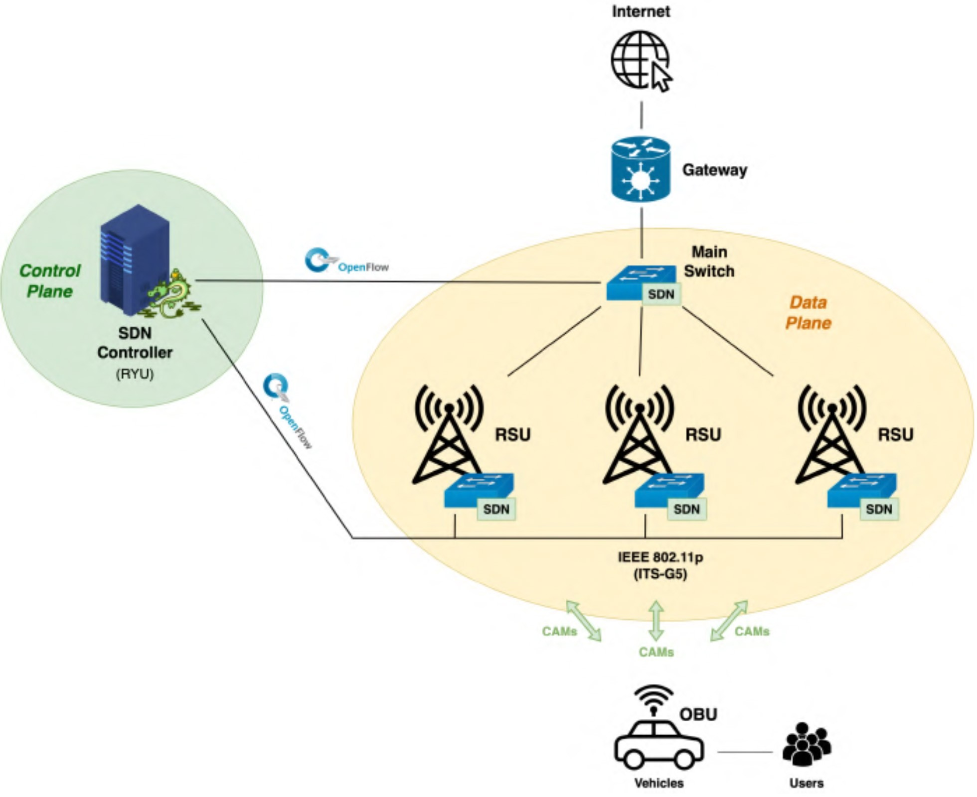

Fig. 7. Software-defined vehicular network architecture.

Fig. 7 depicts the architecture comprising a control plane with a single controller, and a data plane that includes a main SDN switch and RSUs that are also SDN switches. Regarding the control plane, the controller is based on the Ryu SDN framework, which is an Open-Source Software (OSS) system. As for the data plane, the main SDN switch is responsible for interconnecting the vehicle infrastructure (RSUs, OBUs, and end-users) and the gateway that connects to the Internet. The switches communicate with the Ryu controller using the OpenFlow communication protocol [31] to create the flow table, which dictates what should happen to packets arriving at the switches. A custom protocol (OBUInfo) was introduced to differentiate between custom OBUInfo messages (containing the contents of CAM messages plus the RSSI forwarded by the RSUs), which represents control traffic, from IP packets that represent data traffic. Therefore, the controller can sepa- rate both, so there is no need to send control messages within data traffic.

To offer proactiveness in the handover process, the most suitable class of messages are CAMs because they carry sig- naling information, such as location, heading, speed, and type of vehicle. This information is very relevant in the controller because it allows it to have an idea of the movement of the OBUs, thus allowing the prediction of handovers even before they happen. The algorithm under execution in the SDN con- troller that selects the preferable RSU to communicate with the OBU applies the same rules as the VCM described in the end of Section IV-C.

1. *Named Data Network*

The NDN architecture, an example of the information- centric networking (ICN) paradigm, has been considered to be one of the most promising candidates to overcome the draw- backs of host-centric IP architectures whose main flaws are in large-scale mobile distributed wireless environments, such as IoT scenarios due to node mobility, dynamic topologies, and intermittent connectivity [32]. In view of the interest in such communication paradigm, and because there is a clear lack

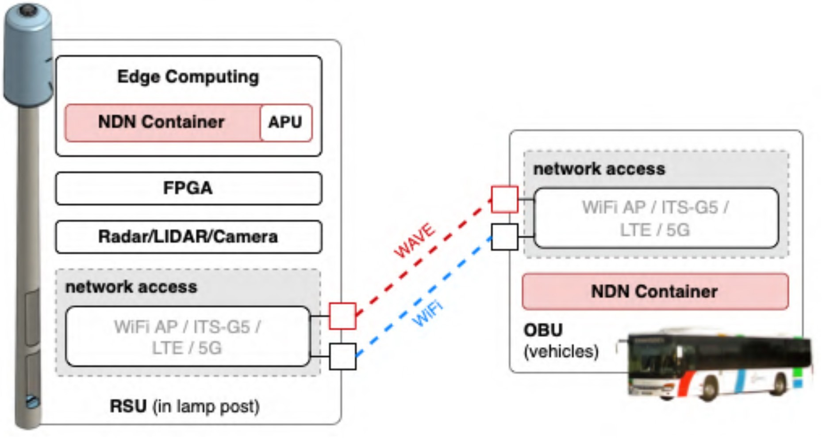

Fig. 8. NDN over ATCLL infrastructure.

of large-scale wireless testbeds covering this topic, we have included it in our infrastructure.

In NDN each piece of data (also denoted as Content) has a unique, persistent, and location-independent name that is directly used by the applications for content search and retrieval. The Content is requested by the Consumer through an Interest packet: once it reaches the Content (in the Producer or cached somewhere), it follows the reverse path back to the Consumer in the form of a data packet. The NDN solution deployed in the ATCLL offers efficient handling of mobil- ity (Producer and Consumer), a context-awareness caching strategy especially designed for mobile IoT network, special handling for IoT traffic, and efficient forwarding strategies including energy-constrained wireless environments [33].

The NDN implementation in the ATCLL is illustrated in Fig. 8 where a lightweight deployment strategy has been adopted using microservices made available through lightweight containers. This strategy allows not only to deploy on demand, but also to include services migration to meet the mobility of OBUs, in addition to facilitate the configuration of devices on-the-fly as needed by the applications. Moreover, using lightweight containers, we isolate the NDN network stack from the TCP/IP network stack, ensuring complete inde- pendence from the operation of the networks. The NDN implementation available in the ndnSIM environment [34] has been ported to our testbed with several adjustments being made for a proper operation of such paradigm in the ATCLL, whose details can be found in [35].

1. COMPUTING/EDGE APPROACH

This section presents more details about the edge infrastruc- ture, specifically the followed approach for the data compu- tation and distribution, and the description of the automated deployment of applications and services.

1. *Edge Support*

As mentioned in Section III-A, the ATCLL MEC has available an Nvidia Jetson Nano or Jetson Xavier with a pow- erful GPU for graphic-intensive processing, and a Raspberry Pi 4 for the deployment of lightweight services. This edge computing capacity is leveraged to maintain several data col- lection and processing services running on the different SBCs installed at each edge node. Some examples include in the following.

Fig. 9. Edge computing data access strategy.

* 1. 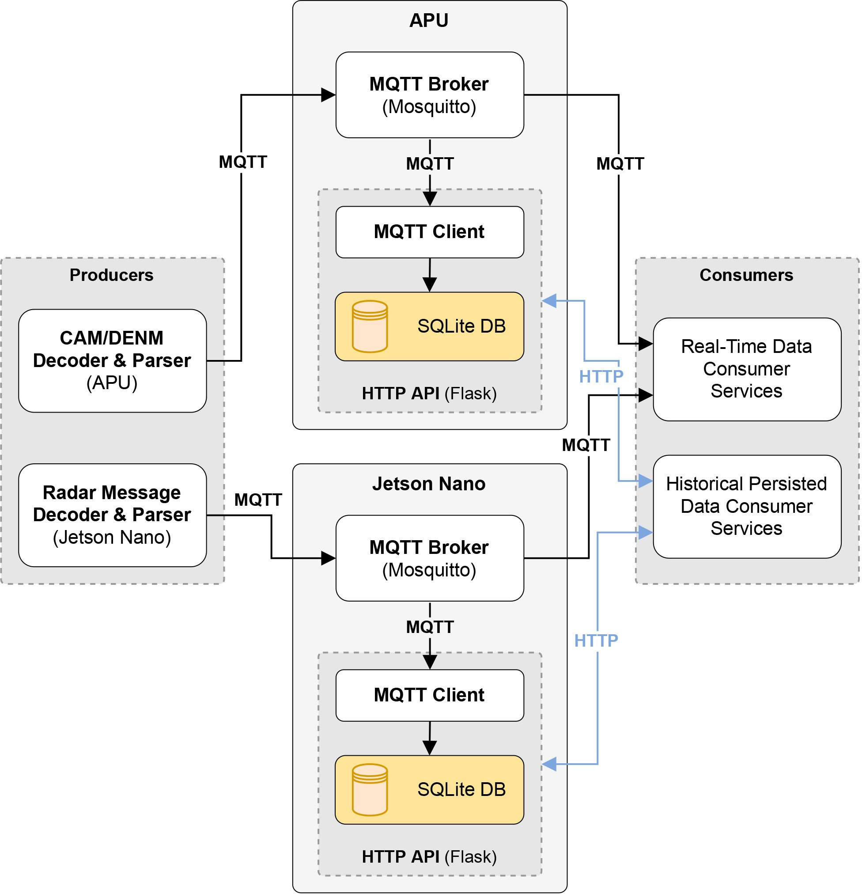Decoding and parsing of the traffic radar message protocol.
  2. Real-time object detection in a video stream (detec- tion of different vehicles, people, and objects visualized through video cameras).
  3. Decoding and parsing of ETSI ITS information in CAM and DENM messages, and interactions with kernel subsystems to ascertain the respective RSSI.
  4. Periodic calculation of vehicle counts and velocity aver- ages for different types of vehicles within specified time frames (separate process for traffic radars, video cameras, and CAM data).
  5. Data fusion processing using traffic radars, video cam- eras CAM data.

Current resource utilization metrics and load averages show that there is sufficient headroom for plentiful future additions. Given that some services must consume the data produced by others in order to work, a comprehensive solution for publish- ing and accessing data is crucial to ensure the effectiveness of the edge computing architecture, while minimizing resource consumption overhead and latency for timing-sensitive work- loads.

Two separate types of data access are supported (the edge strategy for data access is depicted in Fig. 9).

1. *Real-Time Information Stream:* Each edge node hosts a Mosquitto44 MQTT broker to be used by all the equipment and services installed on that particular node. As such, a publisher/subscriber model is used, where producers publish new data points to specified top- ics, and consumers subscribe to the relevant topics and process each new message.

44https://mosquitto.org/

1. *Persisted Historical Information:* Each edge node also hosts an SQLite database configured to persist the real- time data published to a specified list of MQTT topics for a short time period (with a default value of 24 h). This functionality is aimed for data processing services which require complex queries and a complete history of relevant data-points, such as data fusion algorithms. Access to the persisted information is achieved through the use of a REST API developed for this purpose, since SQLite does not natively support multiple concur- rent connections. The choice of SQLite as DBMS over other more feature-rich alternatives is focused on limit- ing excessive resource overhead. Several DBMS-specific optimizations were configured in order to greatly reduce read and write times.
2. *Automated Deployment*

Deploying applications to an infrastructure of this size and complexity presents a number of challenges relating to automation and dependency management, and among oth- ers. These types of deployments can become increasingly harder to manage and maintain, given the high number of nodes and the fact that they are heterogeneous in terms of system architecture, operating system version, and other factors. Moreover, dependency version incompatibilities may occur between services that run on the same compute node. To address these issues, applications are deployed as Docker containers, which package the application code with all of its dependencies and isolate them from the rest of the system. Using this approach, applications can be easily deployed on any Docker-enabled machine in either the cloud or the edge, while maintaining low levels of virtualization overhead. This also greatly simplifies the deployment process for any third-party services that use the infrastructure.

Alternatively, in cases where a transition to a containerised environment has not yet been completed or has been found to be unfeasible, applications can also be deployed as more traditional Systemd services. This type of deployment uses Ansible45 playbooks to ensure a reliable, automated process which includes the installation of the required dependencies, and can be run concurrently on multiple target nodes.

Additionally, the project also leverages CI/CD methodolo- gies and a self-hosted GitLab46 platform in order to auto- matically deploy updated versions of an application to the respective compute nodes each time a new commit is pub- lished to specified production branches. This process includes the automated building of Docker image variants for each CPU architecture (x64, armv8, and armhf) using Docker BuildX and QEMU.

Current work addresses the possible integration of this infrastructure with a more advanced service orchestration framework such as Kubernetes.

45[https://www.ansible.com/](http://www.ansible.com/)

46https://about.gitlab.com/

1. SENSING CAPABILITIES

In the ATCLL, edge nodes can be equipped with multiple sensors with different characteristics. For example, video cam- eras allow the detection and classification of objects with high accuracy levels (e.g., differentiating people from bicycles or motorcycles) but can be affected by weather conditions. On the other hand, traffic radars allow the estimation of objects’ position, velocity, and heading, but the object classification accuracy is lower (compared to video cameras). Furthermore, LiDARs have a much higher resolution than traffic radars, allowing better results in terms of location and classification of vehicles. However, due to the creation of point clouds, the amount of data produced by the LiDAR means that the output data rate is much higher compared to the traffic radar (around 6500 times higher).

1. *Sensors Processing*

Video cameras are one of the most common sensors used to classify objects. In the edge nodes that contain video cam- eras (Reolink RLC-823A),47 a real-time streaming protocol (RTSP) stream is established between the video camera and the Nvidia Jetson present in the same edge node. Each col- lected frame is sent to the Jetson, where it is applied to a set of object detection functions based on a deep learning approach—using a pretrained YoloV3 Model48 or the Nvidia DeepStream SDK Object detector.49 The obtained results are published in the edge MQTT broker, indicating each detected object’s confidence, bounding boxes, and classification.

Traffic radars (Smartmicro50 UMRR-11 Type 44) are used in the ATCLL due to their capabilities to detect and track multiple objects simultaneously, giving information about their position, direction, speed, and length. The radar data is sent to the Nvidia Jetson via UDP packets. In the Jetson, the data is decoded, processed, and published on an MQTT broker, following the edge data strategy described in Section V-A. Although the used radars have already integrated a detection and tracking algorithm, some processing tasks need to be done before the publication: the object’s position is transformed into geographic coordinates, the length allows the attribu- tion of a class to the object (light vehicle, heavy vehicle, and person/bicycle/motorcycle), and the acceleration value is estimated.

LiDARs generate enormous amounts of data in the form of point clouds. The present solution in the ATCLL (with Velodyne Puck51 and Puck Hi-Res52 sensors) allows the detec- tion and tracking of people from LiDAR’s data. One more time it is used the edge data strategy described earlier: the point clouds captured by the LiDAR are transmitted to the edge device where a dedicated process (Neuron) is used to detect pedestrians and retrieve associated information (e.g., location, speed, and direction). These results are then published in the

47https://reolink.com/product/rlc-823a/

48https://pjreddie.com/darknet/yolo/

49https://developer.nvidia.com/deepstream-sdk

50[https://www.smartmicro.com/](http://www.smartmicro.com/)

51https://velodynelidar.com/products/puck/

52https://velodynelidar.com/products/puck-hi-res/

edge MQTT broker. Since real-time point cloud processing is still a hot topic in the scientific community, we aim to extend the detection capabilities in the near future.

In smart cities, data sources are not limited to conventional sensors. Another alternative for the detection of objects, more specifically the detection of flows of people, is through smart- phones and their connectivity—using a technique known as WiFi sniffing. The WiFi APs present in the edge nodes can be turned into monitoring mode to detect the different WiFi terminals around and infer the number of devices connected to WiFi. With this inference, it is possible to detect people carrying their own smartphones or other equivalent devices. Furthermore, vehicle detection is also collected. As described before, OBUs and RSUs exchange CAMs with information of their position, speed, and heading, thus this data is parsed in the edge and published in the local MQTT broker.

1. *Multisensor Data Fusion*

Vehicles, bicycles, boats, people, and other objects can be detected by multiple sources. The usage of several data sources improves the reliability by eliminating the dependency on just one type of sensor.

The first fusion system implemented in the ATCLL fuses radar data with vehicular data (more specifically CAMs col- lected in the RSUs). Note that these two elements are com- plementary: radars have a more limited range when compared to vehicular communication, but not all vehicles are equipped with OBUs to perform that kind of communication. The loca- tion provided by the radar and the location provided by the vehicle OBU are fused using a Kalman Filter, ideal for adjust- ing the weight given to the positional measurement from both sources based on the measurement errors. Since the object location is given in relative coordinates, a conversion pro- cess needs to happen. The fusion algorithm [36] performs time alignment to compensate for the offset time between measurements and performs the fusion taking into considera- tion three main parameters: 1) object class; 2) object location; and 3) object direction. The results allow the creation of a single list with the objects detected without repetitions and integrating the best knowledge of each data source.

The information from video cameras is processed by divid- ing a frame into a set of squares—that effectively are regions of interest—each one with a known fixed global position; an object with a determined bounding box will have a global position corresponding to the square that is within. Since a bounding box of an object may overlap more than one square, the square to be considered is the one which the intersection of union with the bounding box is greater. With this algorithm, an approximation of the location of objects can be obtained by defining the object’s location with the coordinates of the center of the associated bounding box. This information can then be used to detect vehicles and VRUs that any other source could not detect. While the camera, with this algorithm, can only provide an approximated position and not much more information about the VRU or vehicle (such as speed and heading), it can be used as a fall-through sensor to detect with more error potential dangerous situations.

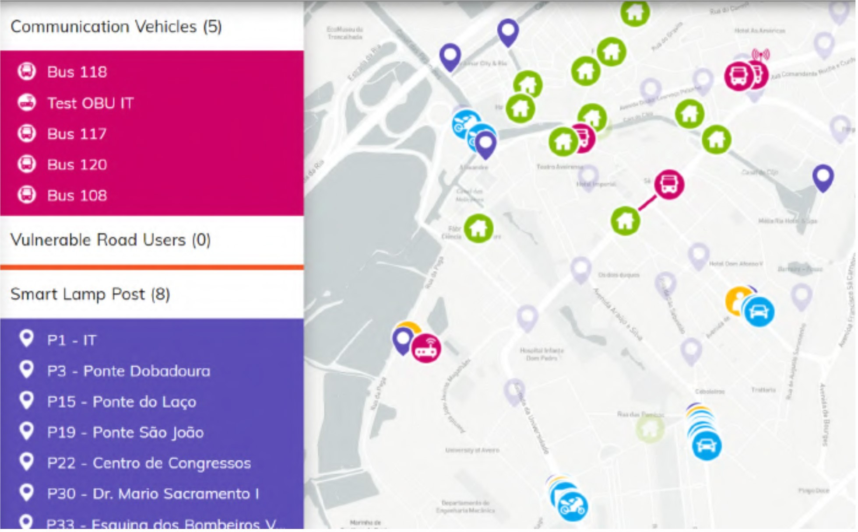

Fig. 10. Screenshot of the ATCLL dashboard showcasing real-time data.

1. RESULTS

This section presents two main types of results: 1) examples of data collected from the sensing and communication devices of the ATCLL infrastructure and 2) performance results.

1. *Examples of Data Collected*

As described in Section III-C, the data is gathered and pro- cessed for real-time visualization and also persisted in the database of the ATCLL data platform. This section will start with a description of the dashboard, which allows for data visualization based on real-time and persisted data. Thereafter, examples of the persisted data are presented, plotted, and analyzed.

* 1. *Dashboard:* The ATCLL dashboard is a key piece of the platform which enables the visualization of the collected data (in real-time and from historical records), geographically, and in plots for representation over time.

An example of the visualization of real-time data is depicted in Fig. 10. The nodes in blue are vehicles detected by the traf- fic radar, which is able to distinguish three classes of objects as of light vehicles, heavy vehicles, and others, including pedes- trians and two-wheelers. The nodes in pink are detected by connectivity (vehicle-to-everything (V2X) or cellular), where pink lines represent the active V2I connection between the vehicle and the respective RSUs. Moreover, the yellow icons represent the detection of objects performed by a video cam- era, whose target can be of several types: pedestrians (as seen depicted in the Figure), bicycles, motorbikes, cars, trucks, and among others.

Additionally, the user is also able to choose the time ranges to visualize historical data. For instance, to visualize the data related to the number of vehicles that crossed a certain area in a period of time, the user may choose the traffic radar data.

* 1. *Traffic Radar:* The first example of gathered data is the information of traffic radars. Traffic radars provide data of the number of vehicles per time that cross a certain area, as well as their type, velocity, and acceleration. Examples of radars are the ones installed in ISCA-UA, and in the Dobadoura bridge (whose installation is similar to the depicted mount- ing in Fig. 3). Figs. 11 and 12 show the average number of vehicles that, in each hour, have crossed Dobadoura bridge

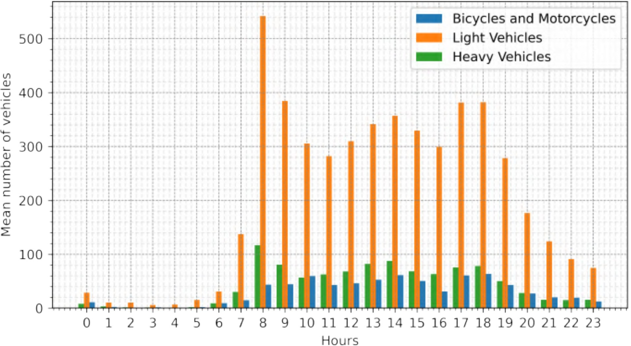 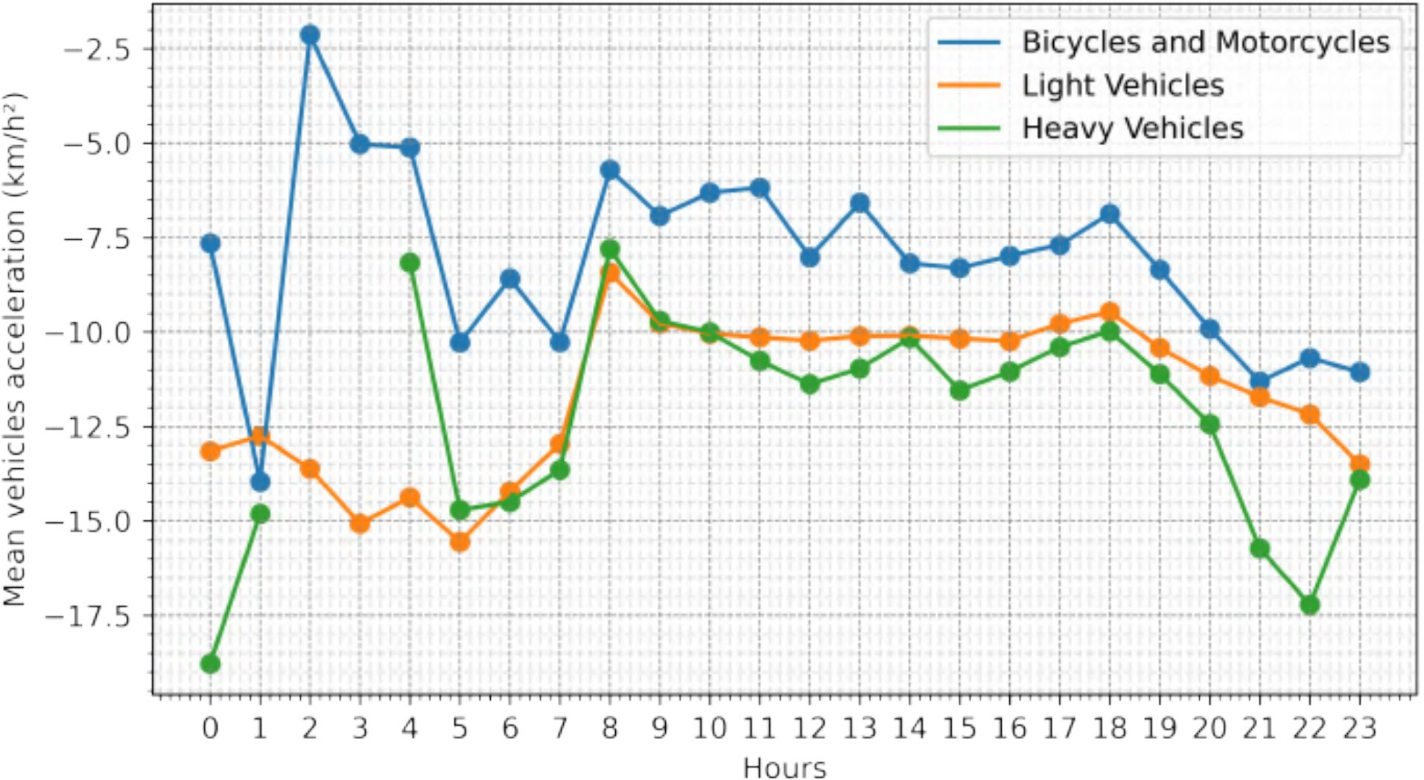

Fig. 11. Hourly average of the number of vehicles arriving to the city through Dobadoura (from 7 February 2022 to 11 February 2022).

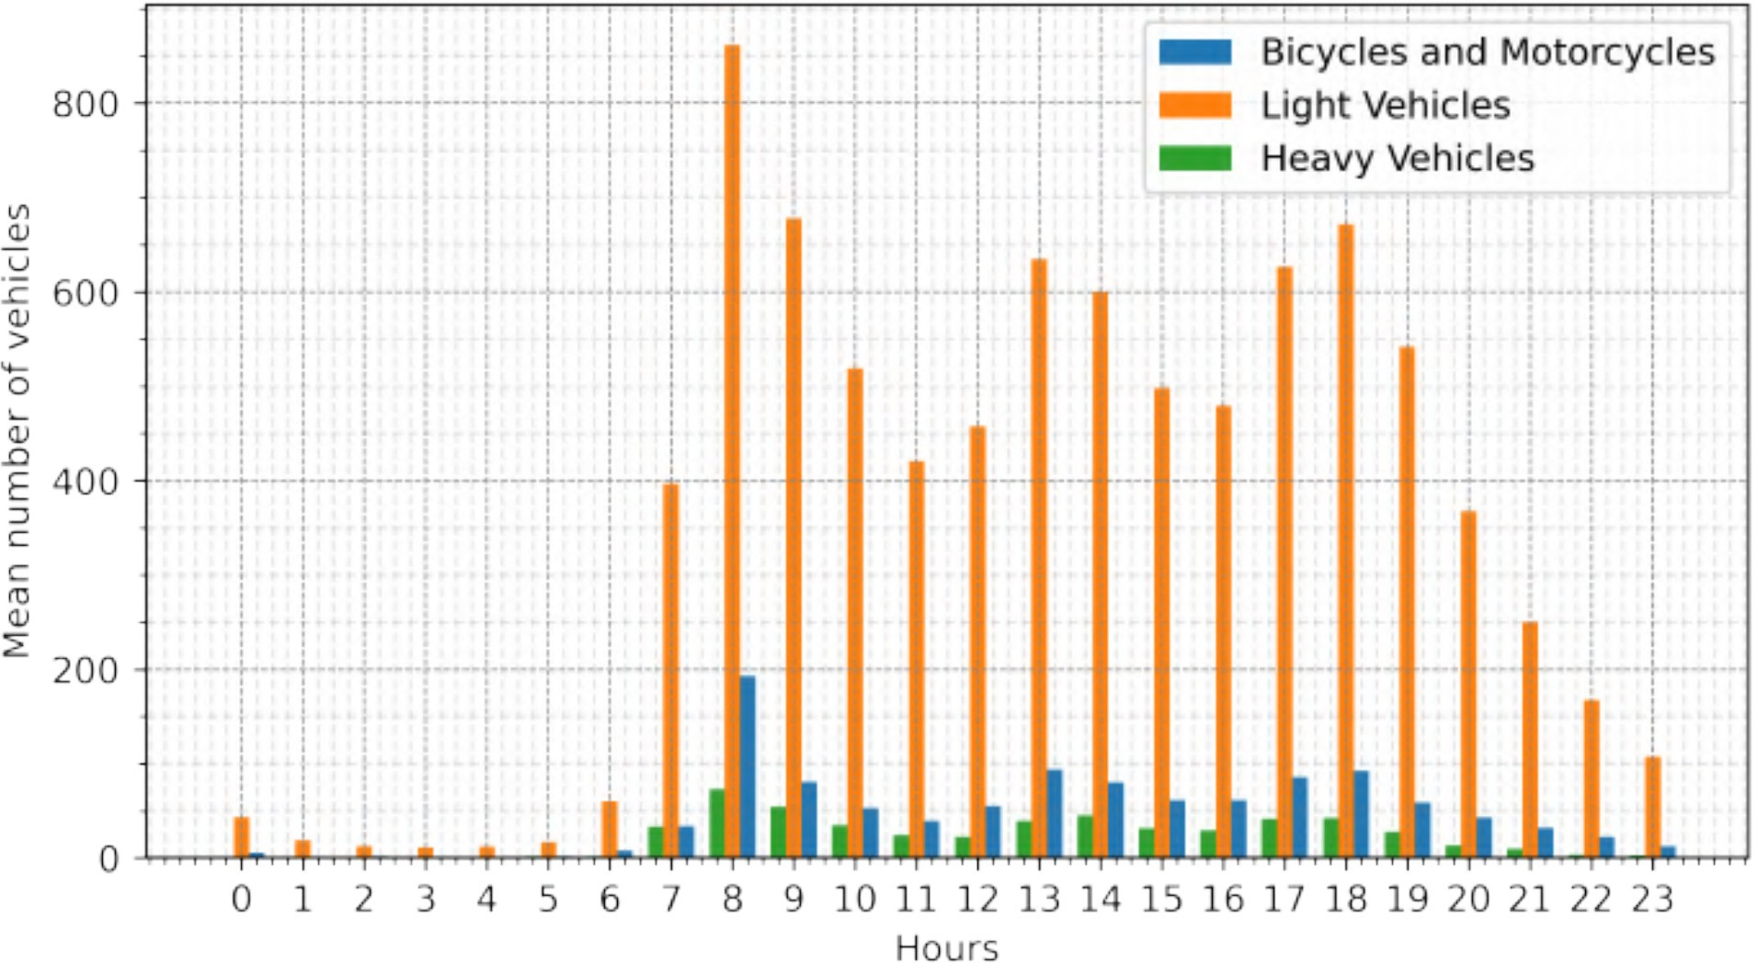

Fig. 12. Hourly average of the number of vehicles arriving to the city through ISCA-UA (from 7 February 2022 to 11 February 2022).

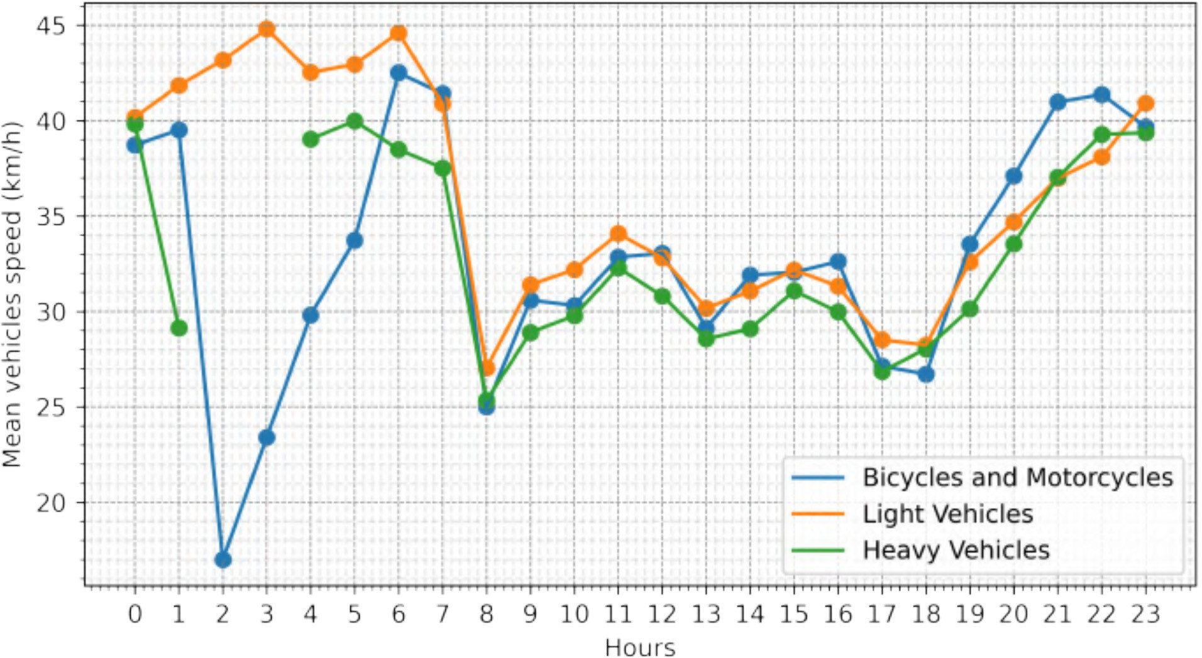

Fig. 13. Hourly average of the vehicle’s speed entering the city through ISCA-UA (from 7 February 2022 to 11 February 2022).

and ISCA-UA, on the week between 7 February 2022 and 11 February 2022. Figs. 13 and 14 show the average speed and acceleration of vehicles which entered the city at ISCA-UA on the same time period.

From this data, we can infer several aspects related to the city mobility. Comparing the number of light vehicles enter- ing the city in Dobadoura bridge and ISCA-UA, we observe almost the double number of vehicles entering using the ISCA-UA access. Moreover, we see that the traffic peak time occurs at the same time for both locations, around 8 A.M. Finally, it is possible to correlate the number of vehicles and their speed/acceleration: during daylight periods, as traf- fic congestion increases, one can observe a reduction in speed values, and a near-constant acceleration in arriving vehicles;

Fig. 14. Hourly average of the vehicle’s acceleration entering the city through ISCA-UA (from 7 February 2022 to 11 February 2022).

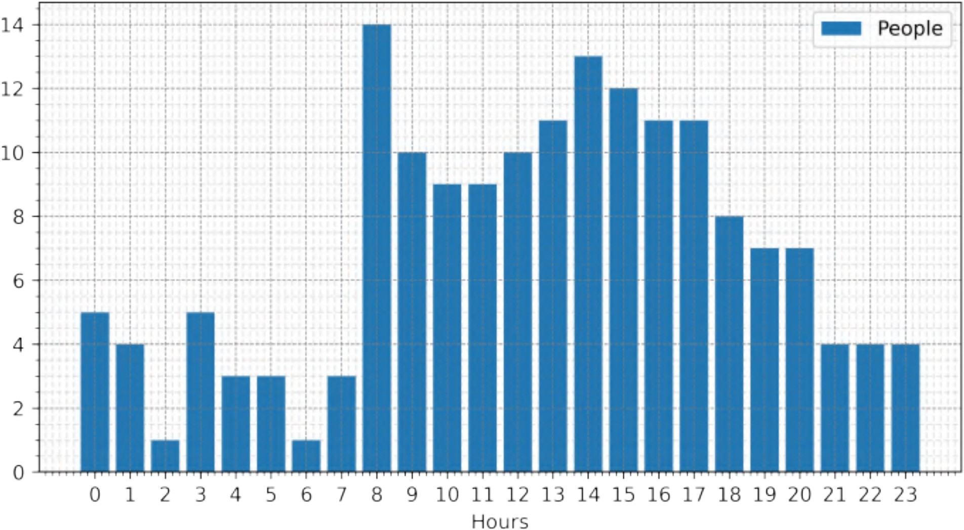

Fig. 15. Maximum number of pedestrians observed in a given video frame in the crosswalk located next to the ISCA-UA (8 February 2022).

on the other hand, in the night periods, no traffic conges- tion is noticed, leading to a higher variance of speed values, consequently causing oscillating acceleration values.

* 1. *Camera:* Another type of gathered information is the video camera detection metadata. Through the vision frame- work running in the edge, already described in Section VI-A, the platform is able to accumulate data regarding the detec- tion of objects from different classes. The results presented in this article focus on the flow of pedestrians in the areas where cameras are located.

In the Smart Lamp Post of ISCA-UA, there is a video cam- era (Fig. 3) capturing a crosswalk located at the end of the road being sensed by the traffic radar. Fig. 15 depicts statis- tics on the detection of pedestrians using that crosswalk. At each instant of the detection, the number of distinct people is counted and the maximum of these values, per hour, is plot- ted. With this data it is possible to analyze some correlation between Figs. 12 and 15. When more people are detected, for instance at 8 A.M., the vehicles’ average speed is lower. There are some studies already in place by the municipality of Aveiro regarding this intersection, to evaluate the impact of the crosswalk occupation in the vehicles traffic exploring the information collected by the radar and the video camera.

Another video camera is located in the Smart Lamp Post close to the city hall, pointed to a city leisure park. Fig. 16 depicts the hourly average number of people detected, for a span of one week. The idea was to compare two weeks— one from Summer (starting in 23 August 2021) and another

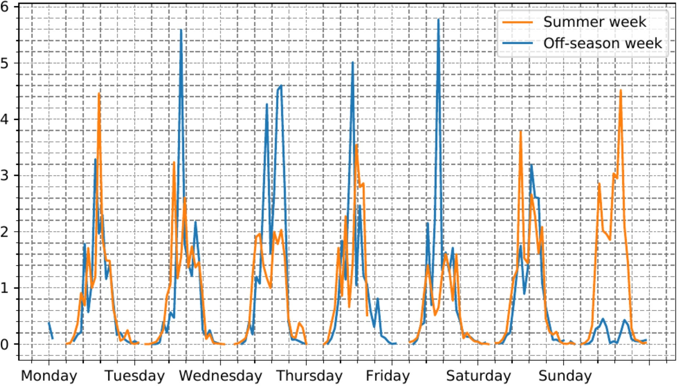 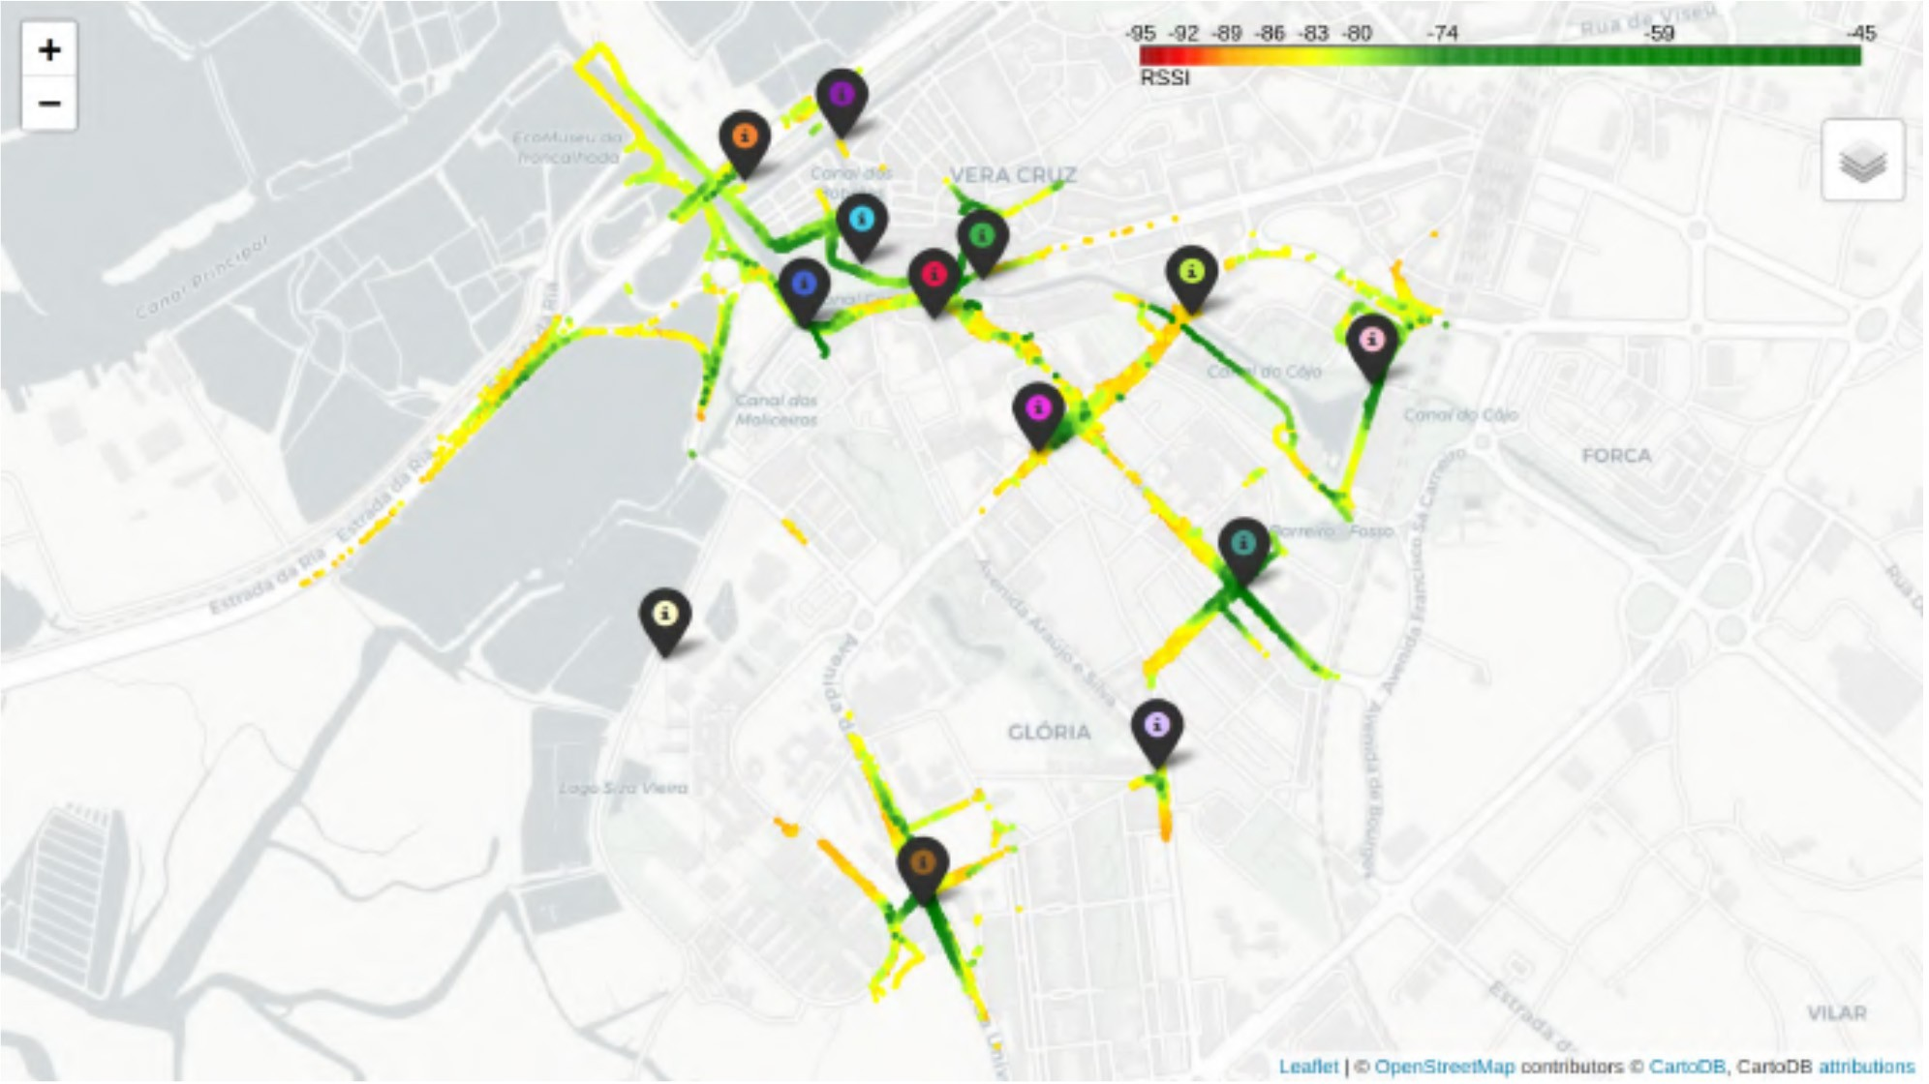

Fig. 16. Hourly average number of people at city hall in two weeks (Summer week of 23 August 2021 and off-season week of 7 February 2022).

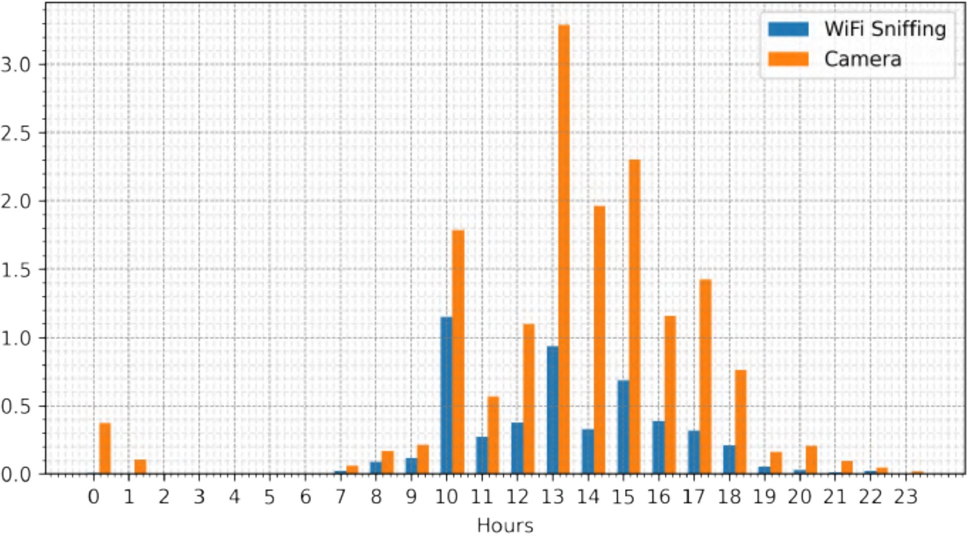

Fig. 17. Hourly average of the number of people detected: WiFi sniffing versus camera at city hall (7 February 2022).

off-season (starting in 7 February 2022). The most notori- ous difference lies on Sundays where, during the Summer, the number of people in the park is higher for the entire day when compared to the Winter season.

* 1. *WiFi Sniffing:* As described in Section VI-A, the WiFi sniffing service uses one of the RSU’s wireless network adapter, set in monitor mode, so that it can capture probe requests emitted by the devices that pass near the posts. Assuming that most people carries at least one device with WiFi capabilities, the collected data allows to understand which are the hours when more people are passing by the monitored areas. It is also possible to correlate this data with the detection of the video camera. Fig. 17 plots the results for the WiFi sniffing of devices and video camera detection of pedestrians in the Smart Lamp Post close to the city hall. It is important to note the following differences between these two types of detection: 1) the WiFi sniffing can capture more than one device per person emitting packets trying to join a WiFi AP, and it does the detection in an omnidirectional coverage and 2) alternatively, the camera identifies each person, but in a range-defined area. Thus, despite different absolute values, it is still possible to correlate the trend of the amount of people in different hours throughout the day.

1. *Performance Results*

The second set of results are related to the performance of the vehicular network and the edge computing.

Fig. 18. Average RSSI of CAM transmissions, as measured on the RSUs.

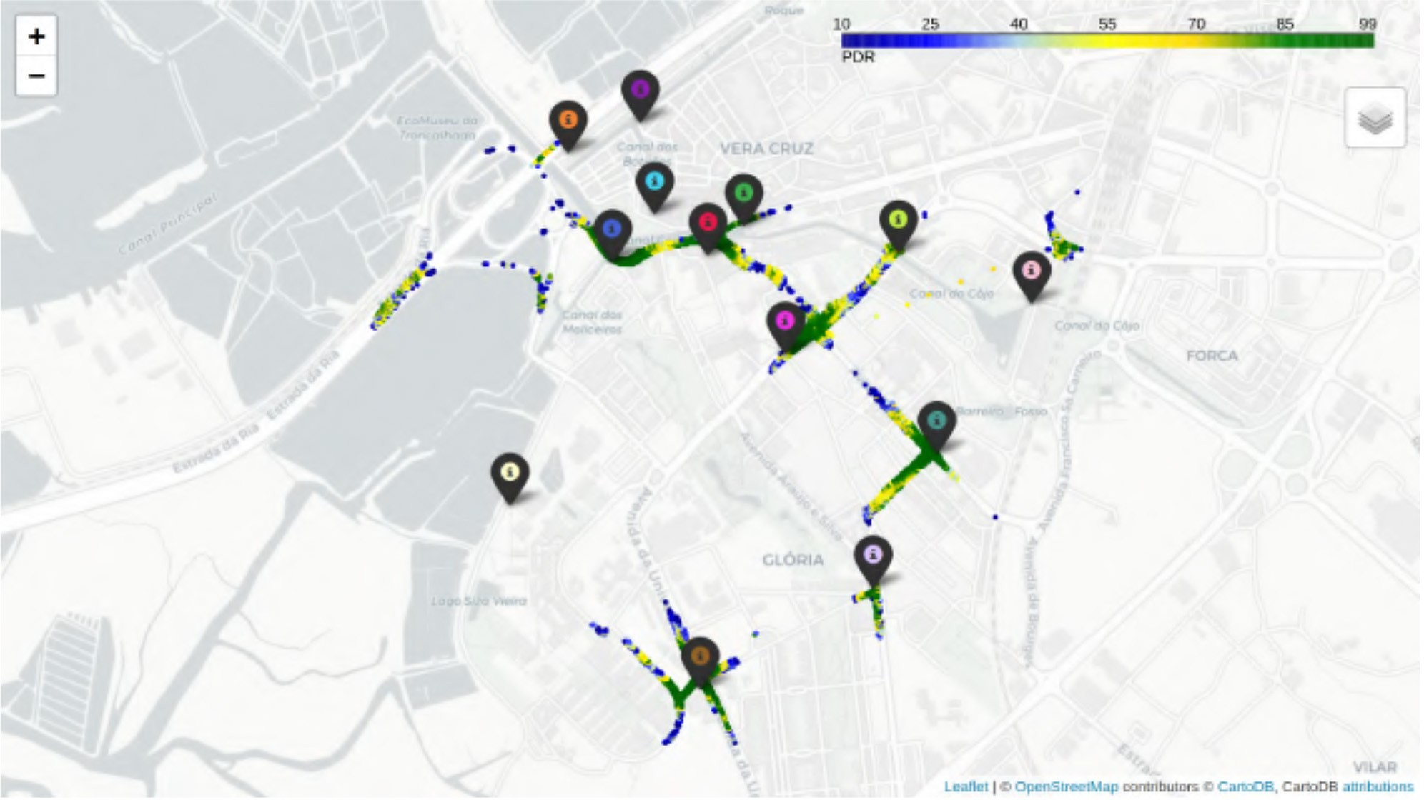

Fig. 19. Average PDR of CAM transmissions from vehicles whose transmission rate is known.

* 1. *Vehicular Connectivity:* To obtain initial results on both levels of ITS-G5 coverage and signal quality, maps with results of RSSI and PDR were generated based on CAMs collected during working days (on the week of 12 April 2021). Fig. 18 plots the average RSSI measured on the RSUs. For these results, all received CAMs are considered, including those transmitted by the buses with ATCLL’s OBUs, and conven- tional vehicles supporting ITS-G5. We can observe a good coverage nearby the RSUs, in particular in the city center where the density of nodes is higher. Regarding the PDR results, the measurements are shown in Fig. 19. Here, third- party CAMs were discarded in favor of messages originating only from buses with ATCLL OBUs, since the CAM’s trans- mission rate is preknown. For this reason, the measurements are plotted in a smaller amount of roads. Once again it is pos- sible to observe a high PDR nearby the RSUs and in the city center, with more density of nodes.

To evaluate the performance of the initial version of the SDN-based mobility network (Section IV-E), measurements were performed in the following manner: an iPerf353 server is running in each ATCLL OBU of the city buses, and an iPerf3 client deployed in a virtual machine, in the core platform, is continuously trying an UDP connection to all OBUs (through the RSUs, using ITS-G5). Upon a successful connection, traf- fic is generated from the OBU at the packet level, accurately replicating appropriate stochastic processes. The tests were performed with a duration of 1 s per test, with tests being

53https://iperf.fr

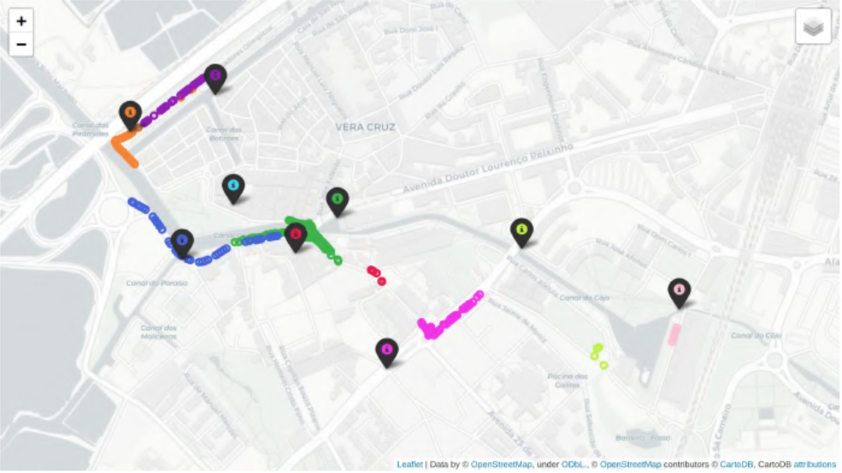

Fig. 20. Connectivity tests regarding the vehicular network assessed by a single OBU in a specific track. The colors represent the connected RSU for that location.

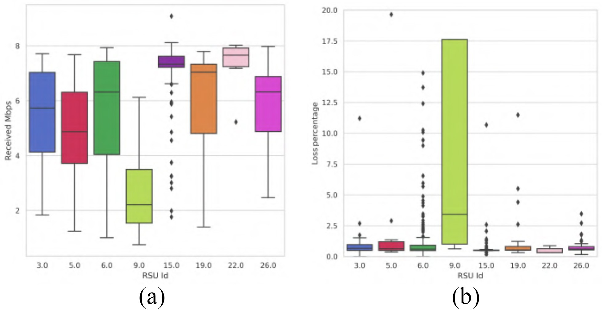

Fig. 21. Network statistics regarding the vehicular network. (a) Received Mbps. (b) Loss percentage of packets.

carried out with a frequency of 1 Hz. The OBUs carrying the testing platform circulated through RSUs numbered P3, P5, P6, P9, P15, P19, P22, and P26, as depicted in Fig. 20. RSUs P3, P15, P19, and P22 are located in Smart Lamp Posts and RSUs P5, P6, P9, and P26 are located in wall boxes. Fig. 21(a) depicts the boxplots of the throughput received by each RSU, and Fig. 21(b) depicts the loss percentage of pack- ets for those transmissions. With such results, we can observe that the RSU P9 receives less data than other RSUs. This result can be explained by the fact that RSU P9 is positioned under a bridge, providing less coverage than the other wall boxes placed on top of buildings.

Fig. 22 shows the results of throughput over time and dis- tance traveled in one trip done by a vehicle, passing by several RSUs (P3, P5, P6, P19, and P26). As corroborated by the results, the current solution of connectivity between OBUs and infrastructure performs well in long periods of connectiv- ity, frequently achieving a peak throughput of, at least, 8 Mb/s. These results are also plotted in the map of Fig. 23, demon- strating city locations where the communication level was sufficient to establish connectivity for the UDP tests, with data on the reception rate (in Mbps) for each position.

* 1. *ITS-G5 Versus Cellular Coverage:* Using a bus with an OBU supporting both ITS-G5 and cellular (LTE/5G) connec- tivity, it was possible to plot results of coverage of the different technologies throughout the city. Fig. 24 depicts, in different colors, which technology the OBU used in different areas of the road map of the city. The OBU was able to use ITS-G5 (in

Fig. 22. Collected throughput, received by the OBU, during the connectivity tests over the vehicular network. The different colors represent the connected RSU for that time instant (a), or distance traveled (b). (a) Throughput over time. (b) Throughput over distance.

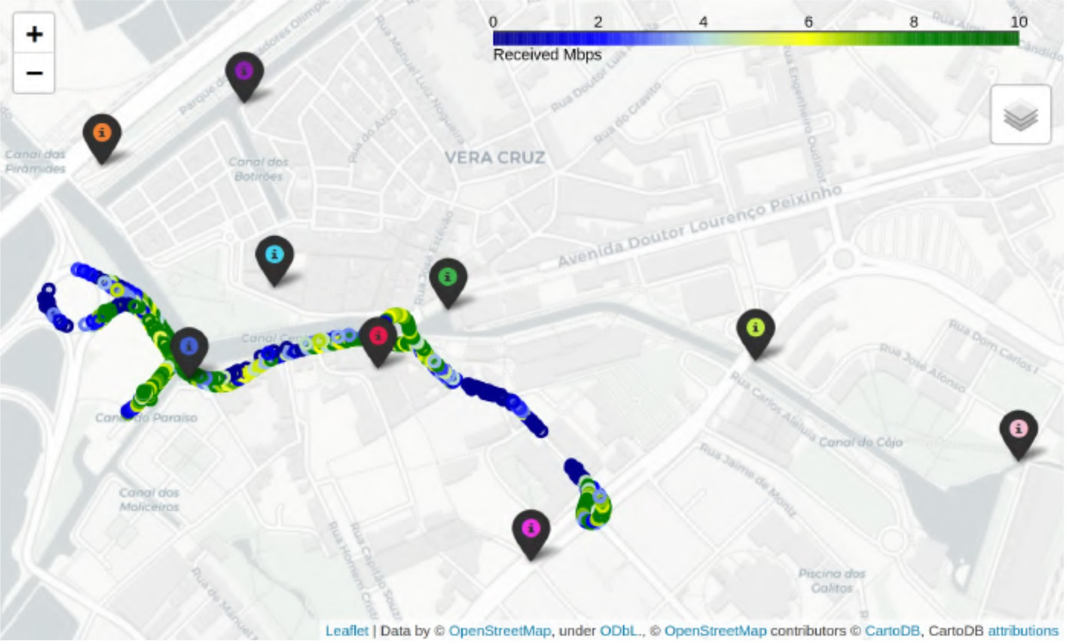

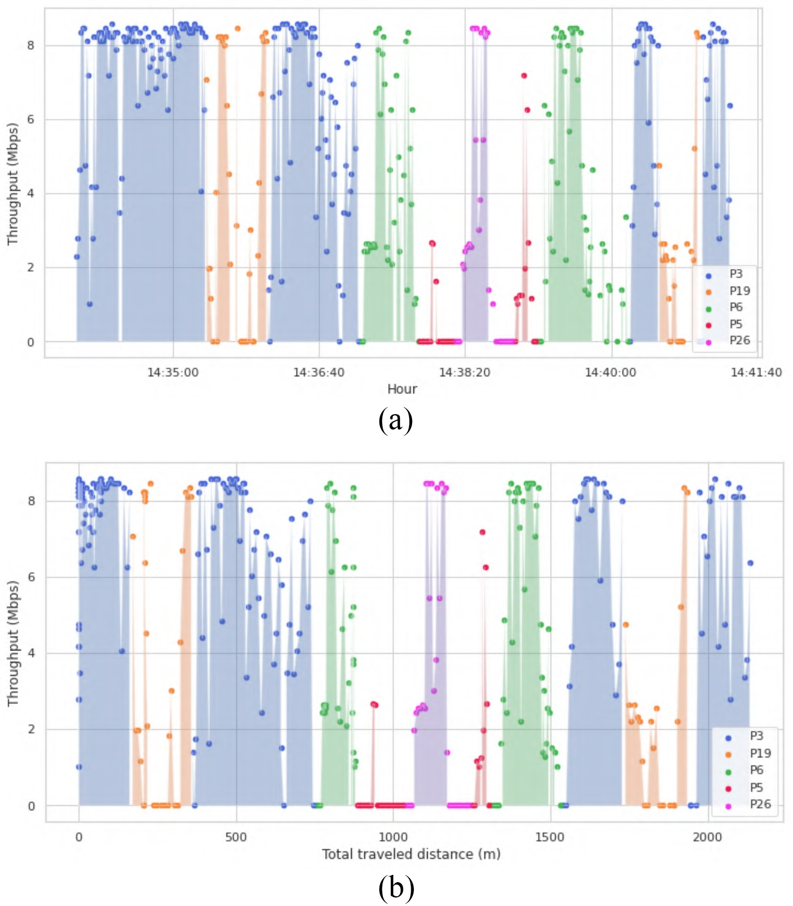Fig. 23. Reception rate (in Mbps) observed in the connectivity tests over the vehicular network, mapped in the city of Aveiro.

blue) when traveling close to an RSU, and changing to 5G (in green) mostly in the other areas. LTE (in red) was used only when the other technologies were not available. The cellular network used in this evaluation was a nonstandalone precom- mercial 5G deployment of the mobile network operator Altice MEO (n77 frequency band).

* 1. *Edge and Cloud Approach:* In order to demonstrate the performance of running services in the edge or in the cloud of the infrastructure, we performed a specific scenario of peo- ple detection in the road through video cameras [37]. Fig. 25 depicts the architecture of this scenario: a person (hereby con- sidered as a VRU) is approaching a crosswalk; next to the VRU there is a Smart Lamp Post equipped with a video cam- era, capturing images from that area. The connectivity between

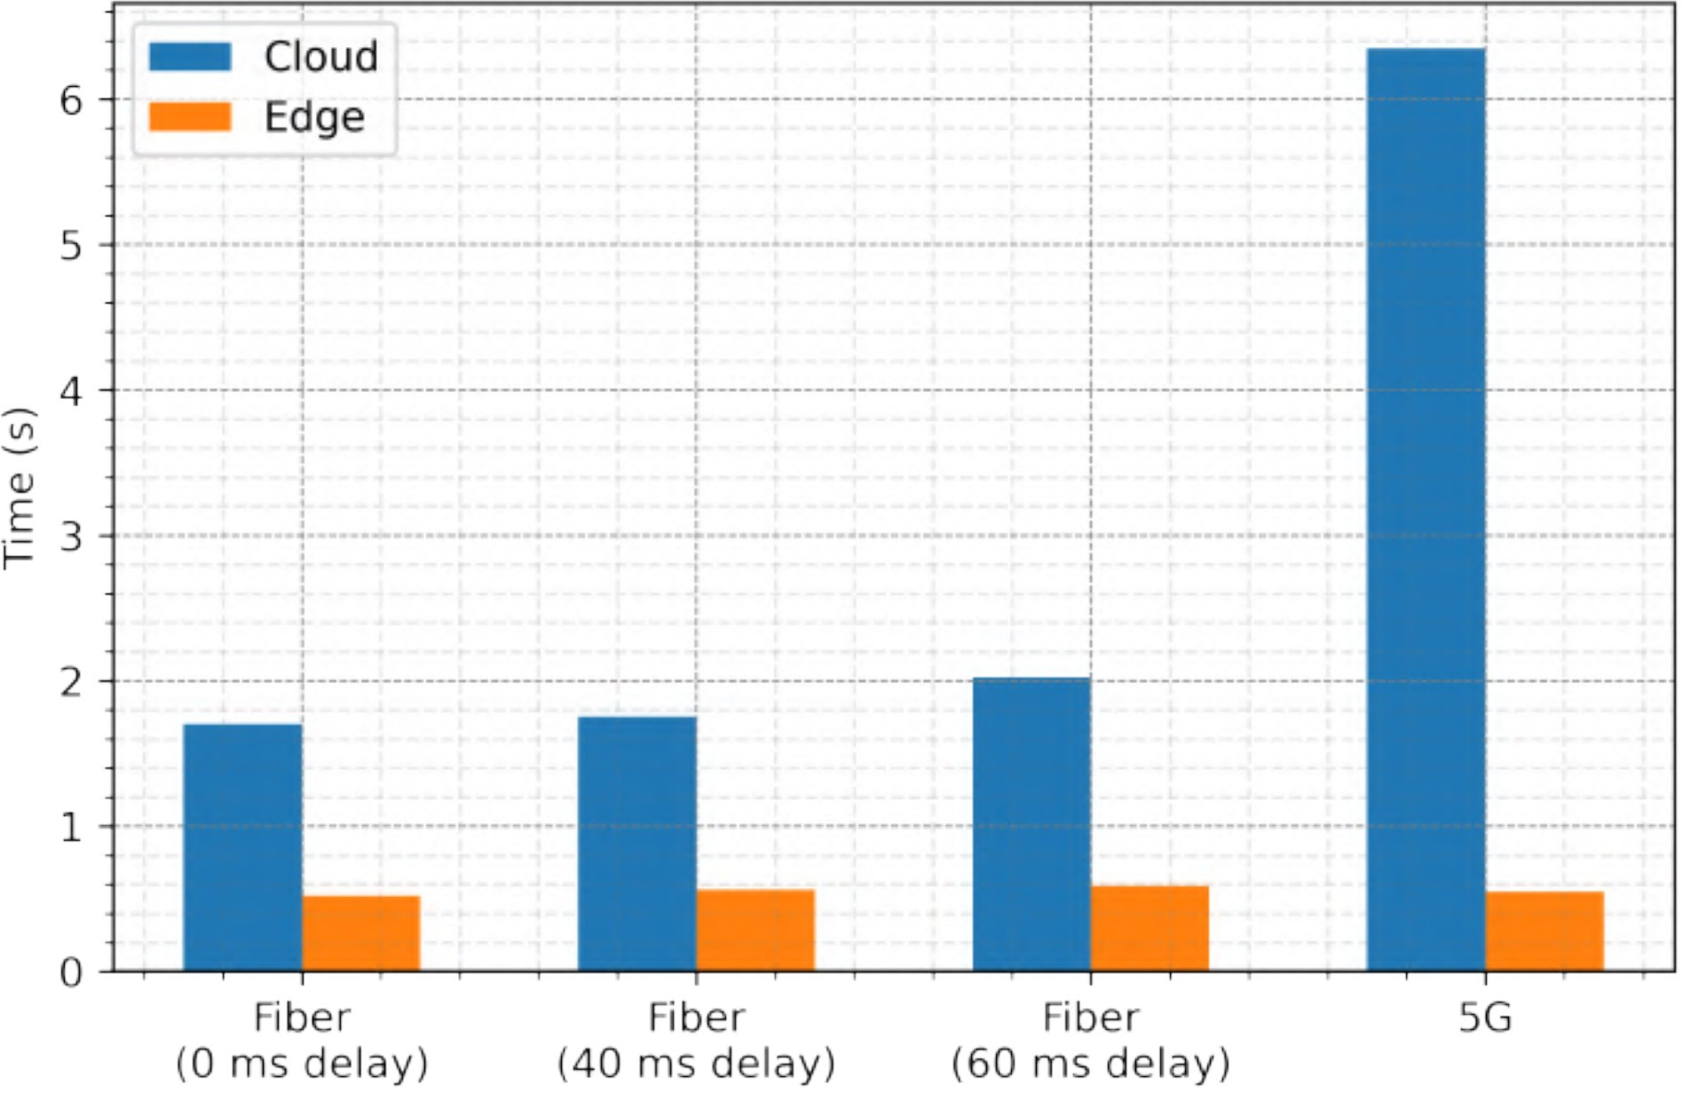

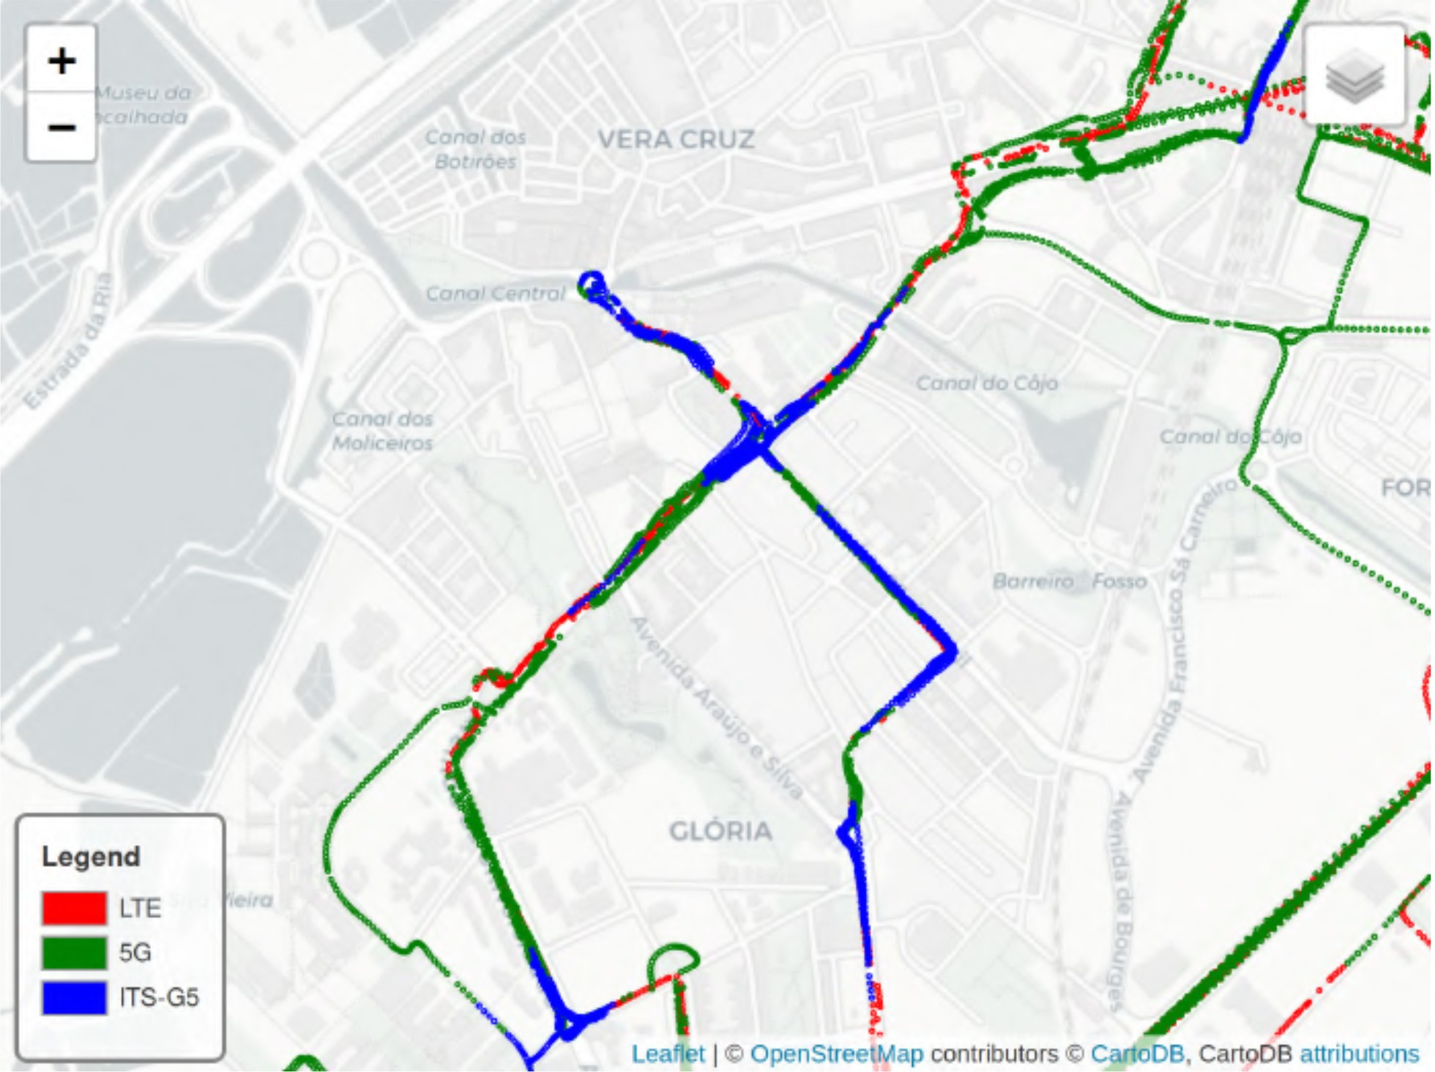Fig. 24. Access technologies for a bus with cellular and ITS-G5 connectivity.

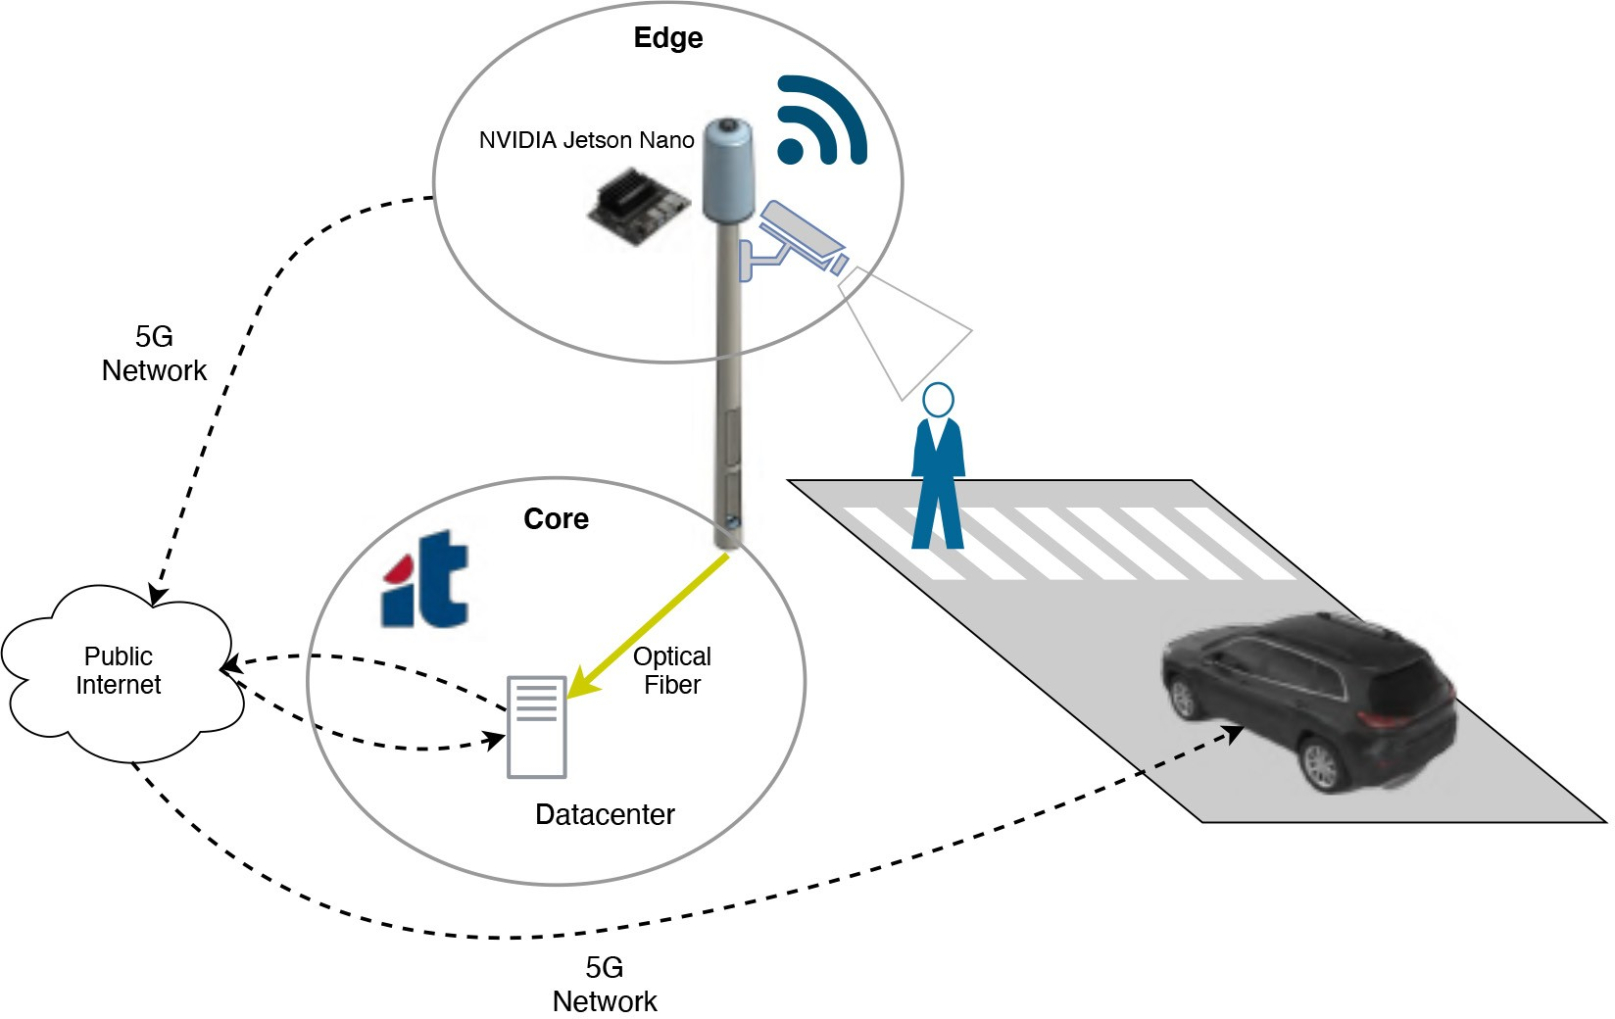

Fig. 25. Camera detection architecture diagram [37].

the Smart Lamp Post and the cloud is assured by two ways. Following a traditional approach, the Smart Lamp Post is con- nected to the core through ATCLL infrastructure optical fiber. Alternatively, to consider some situations where the installa- tion of optical fiber is not available, we assume that the RSU could use 5G network as backhaul connectivity. We evaluated this architecture in a real scenario with real users and vehicles in the area. The 5G technology is the same precommercial network mentioned before.

Fig. 26 compares the detection being processed in the edge and in the cloud with TCP packets. For each bar, the results were obtained by adding the delays of each of the steps that make up the solution flow: the capture delay from the camera becoming available at the Nvidia Jetson; the detection module delay; and also the communication delay between the edge and the cloud. The difference between the results on the edge and the cloud is noticeable, with both the processing and the communication times showing up a strong reduction in the edge-based variant. In the edge approach, only a notification with the detection results (with a length of 41 data bytes) is sent to the cloud. In this case, comparing the performance of the 5G network with the usage of fiber, these delays are now very close. This result is relevant if the 5G option is used preferably due to the stronger flexibility on the positioning of the video camera throughout the city.

Fig. 26. Detection delay in the edge and cloud for the camera detection module [37].

1. USE CASES

To demonstrate the potential of the communication, com- putation, and sensing platform presented in the ATCLL, we demonstrate a set of different use cases, targeting different verticals ranging from mobility characterization up to collision avoidance and safety of VRUs, including also the assessment of new communication technologies (mmWave) and commu- nication paradigms (such as NDN). For each use case, we specify the ATCLL components and the collected data used on its implementation.

1. *Use Case 1: Mobility Characterization*

Managing traffic can be a difficult task. Traffic jams and parking difficulties are some of the problems citizens can face in an urban scenario. To help city managers improve urban mobility, the collection, processing, and analysis of vehicular data become critical.

To study traffic congestion, we created a model based on vehicle speed and count. The needed information to perform this study is provided by the messages exchanged in the vehic- ular network, in particular, CAMs and the multiple sensors spread throughout the city (e.g., radars and LiDARs). Note that all this information is available in the ATCLL, once the infrastructure collects, processes, and saves all this information (as presented in Section VI-A).

Using data clustering techniques, we detect different con- gestion levels as depicted in Fig. 27. The higher congestion level cluster has the higher number of vehicles and lower speeds. This information can then be mapped into road seg- ments, enabling the identification of congestion zones. This way, it is possible to understand traffic congestion and identify temporal and spatial patterns.

1. *Use Case 2: Collision Avoidance With Vulnerable Road Users*

VRU are particularly susceptible to accidents with vehicles. To minimize potential collisions, a system capable of detecting potential accidents was developed [38]. Fig. 28 shows the sce- nario where a vehicle and a pedestrian (VRU) are in a potential collision situation. The system goal is to notify both the VRU

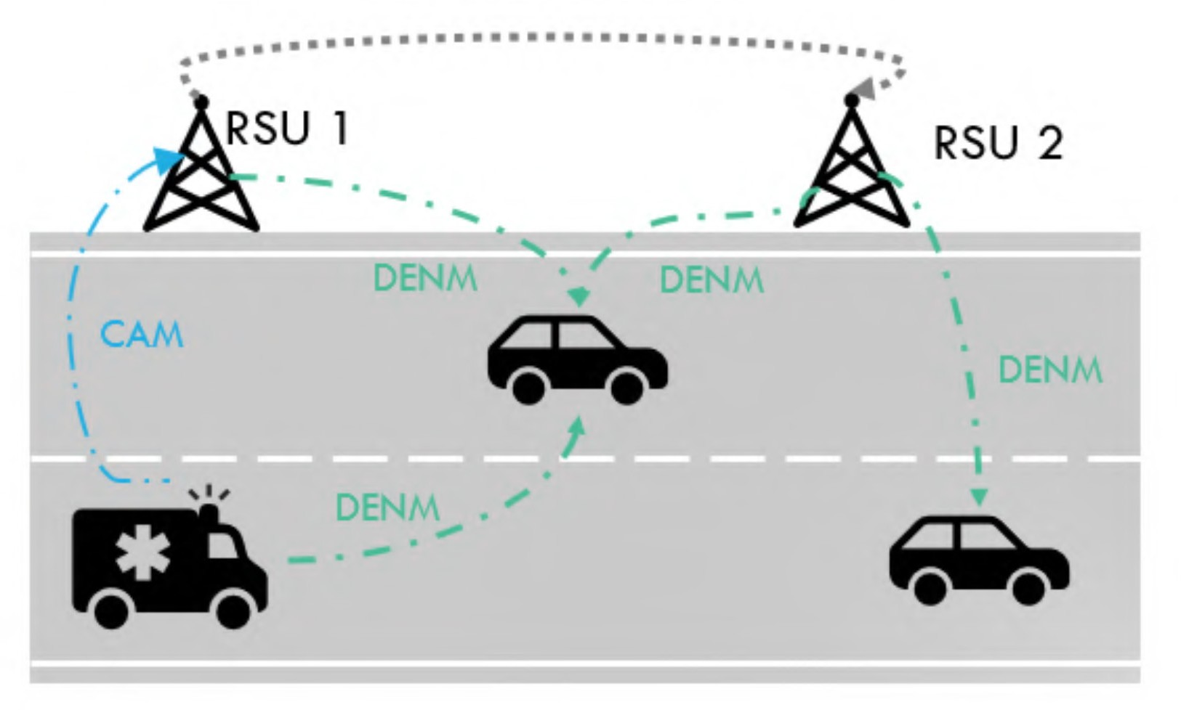

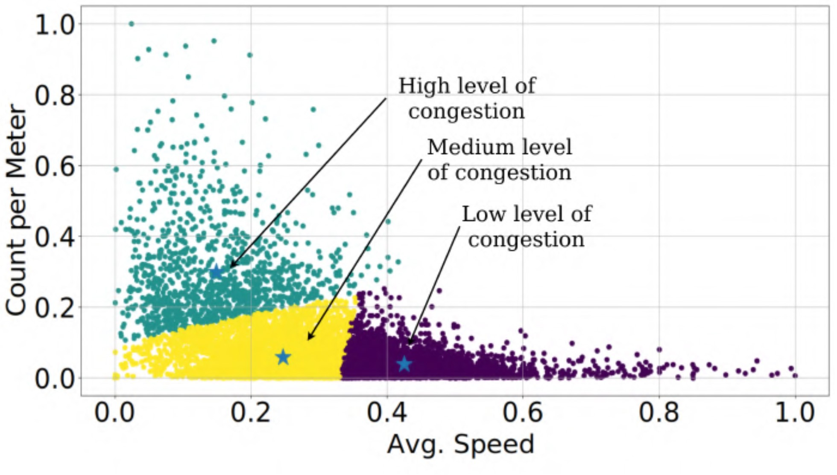Fig. 27. Clustering results regarding the vehicle’s speed.

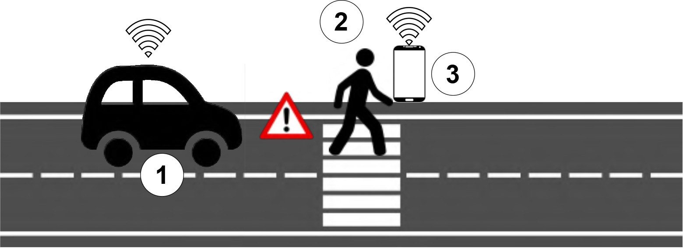

Fig. 28. Vehicle (1) and a pedestrian (2) are warned about a potential colli- sion. The pedestrian has an ITS-S-capable device, e.g., a smartphone (3) and the vehicle and OBU [38].

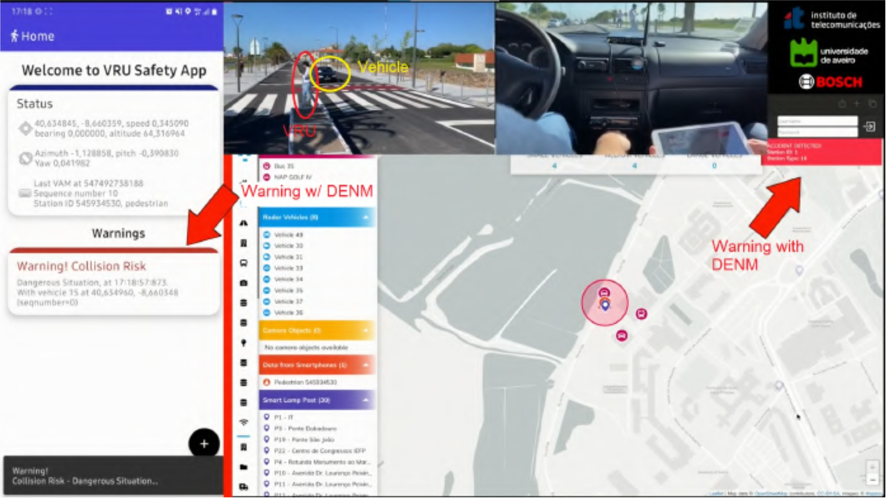

Fig. 29. VRU test execution and results [38].

and the vehicle about an imminent accident. The notification’s overall end-to-end latency must not exceed 300 ms [39] to be possible to adopt strategies to solve the situation (either slowing down, braking, or changing direction, among other actions).

The system uses the multiple data sources (traffic radar, LiDAR, camera detection, vehicular messages, and the VRUs own smartphones), the edge and cloud resources present in the ATCLL to predict potential collisions, and the vehicular network to transmit the warnings.

Fig. 29 presents the visual results of a real test, showing the warning in both the VRU and vehicle, through the VRU ITS-S smartphone application (left) and the ATCLL dashboard (right), respectively. Moreover, the end-to-end delay was cal- culated for both alerts received by the vehicle and received by the VRU, obtaining the values of 146.72 and 127.04 ms, respectively.

Fig. 30. Message dissemination when an ERV approaches.

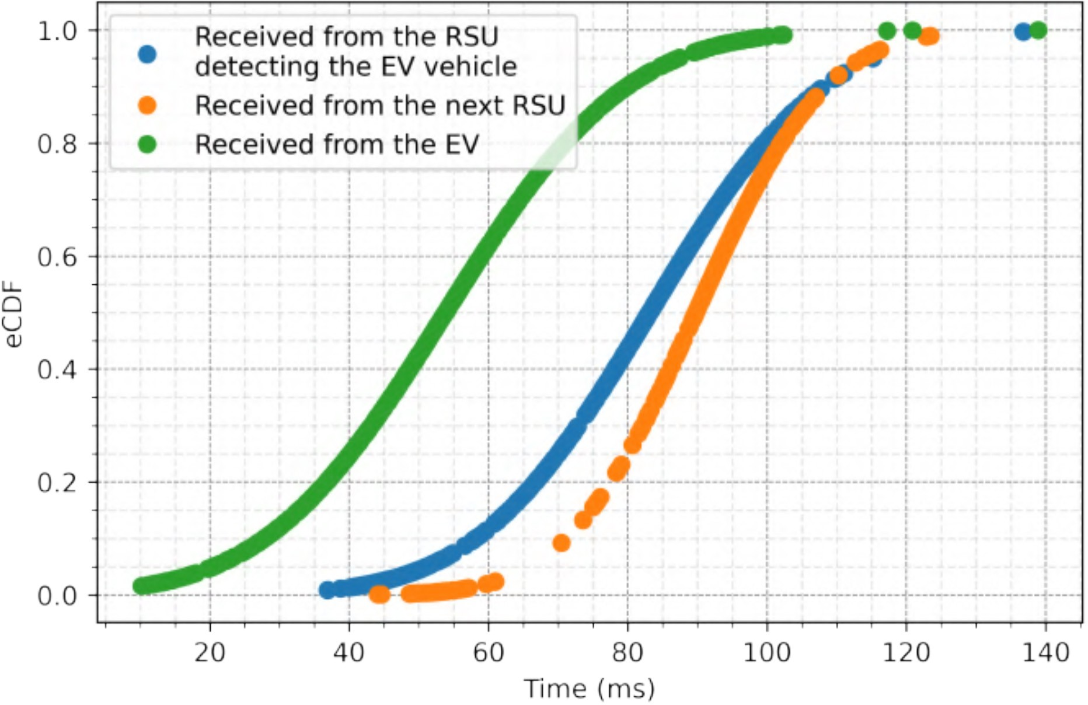

Fig. 31. Message dissemination latencies [36].

1. *Use Case 3: Emergency Response Vehicles Communication*

Nowadays, when an emergency response vehicle (ERV) responds to an emergency, it alerts the road user of its pres- ence through sound and light. However, road users can only detect its presence when the ERV is nearby, making it diffi- cult to clear the road as quickly and safely as needed without interfering with the ERV course. To minimize the delay in the ERV route, a system that automatically alerts road users near an ERV was developed [36]. As so, the system’s goal is to warn drivers about the approach of an ERV. This warning is sent through the standard messages DENMs. Fig. 30 shows a set of messages that allow the detection of ERVs by the infrastructure (CAMs), and the messages sent to alert the road users near an ERV (DENMs).

To evaluate the system, tests in the ATCLL were performed. One of the evaluated metrics was the delay between the detec- tion of an ERV and the reception of a DENM by other road users. Fig. 31 presents the empirical cumulative distribution function (CDF) of the system’s total delay for three different DENM transmitters: 1) the ERV; 2) the RSU detecting the ERV (e.g., RSU 1 of Fig. 30); and 3) and the upcoming RSU (e.g., RSU 2 of Fig. 30).

When the ERV sends the DENM, it obtains the lowest delay of the three cases; however, it also obtains the smallest deliv- ery range. On the other hand, for the case where the RSU is responsible for the DENM transmission, both the range and the delay time increase. In the worst case, i.e., when it is the upcoming RSU to send the DENM, it is received with a

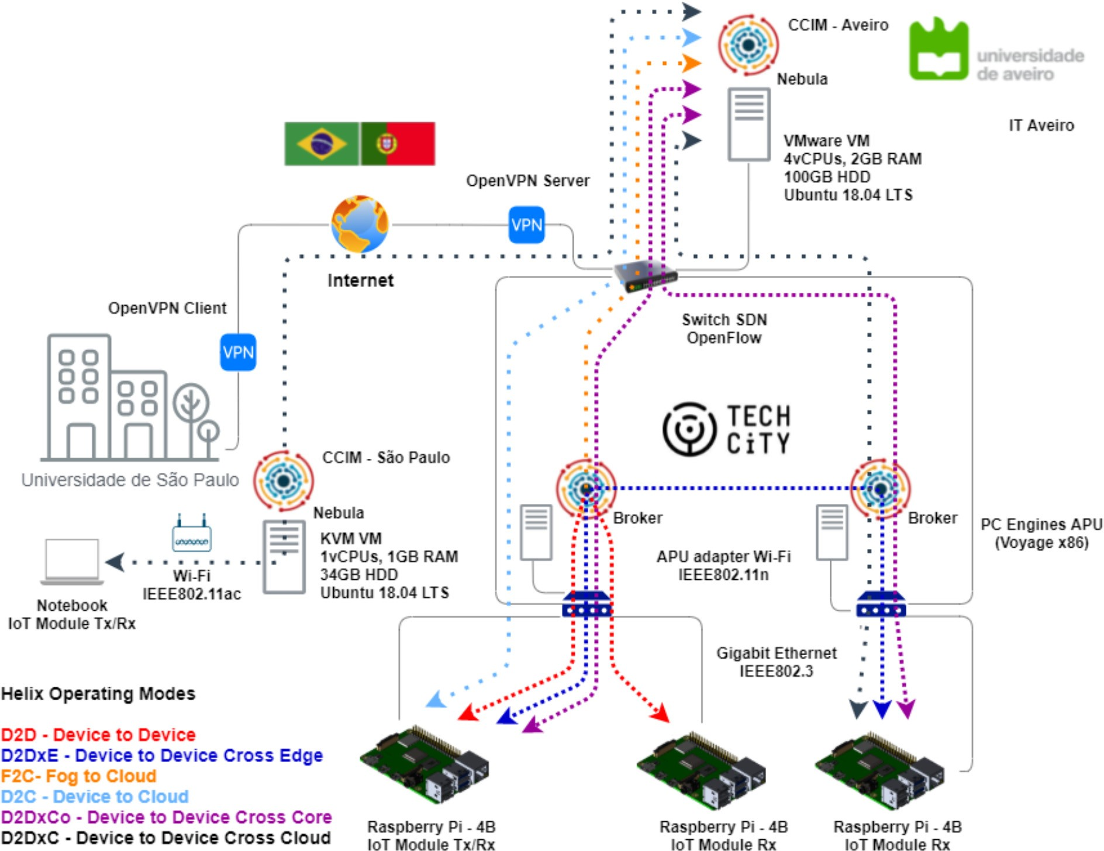

Fig. 32. Infrastructure used to evaluate the Helix Multilayered platform at the ATCLL [41].

maximum delay of 108 ms (in 90% of the cases) and a median time of 89 ms.

Note that this system relies on the transmission and pro- cessing of standard vehicular messages that the ATCLL already implements, allowing easy integration with this system. Additionally, the traffic data collected in the ATCLL (Section VII-A) allows the ERV to receive real-time information about highly congested areas from the infrastruc- ture, planning its avoidance.

In the future, we are hoping to expand this emergency use case from a vehicle’s communication scale to a full-city-scale, where TSN nodes [40] are also expected to allow latency- and jitter- strict emergency communications to happen, bringing the time concept toward our infrastructure.

1. *Use Case 4: Industrial Internet of Things to Cloud Continuum*

We implemented a use case targeting IoT applications, more specifically the industrial Internet of Things (IIoT), showcasing a real-world deployment, in partnership with the developers of the Helix Multilayered IoT platform.54 The Helix platform was deployed and evaluated in the ATCLL to identify its potential to support services and applications that require operation in an edge environment, as depicted in Fig. 32.

This implementation took advantage of the usage of the Raspberry Pi 4 devices of the MEC (collecting sensing data), brokers deployed throughout the infrastructure (Aveiro edge, Aveiro core and São Paulo, Brazil core), core services and vir- tualization capabilities of both cores, RSUs’ WiFi access, and more. This use case was also important to validate the capa- bility of the ATCLL platform to deploy third-party services in shared hardware, and also to demonstrate the effectiveness of providing external access to the devices and to connect the ATCLL data platform with external brokers.

The experiments showed a slight increase in latency in the modes between edge nodes, when comparing to controlled lab

54https://gethelix.org/

tests, suggesting that the presence of concurrent processes on real IoT devices has an expected impact on latency. In the cases involving communication through the cloud, since the connectivity latency is more representative, the variation of the total delay was negligible. In particular, the mode connect- ing the devices between different countries showed a typical Internet latency. More detailed results of the integration of the Helix platform and its operating modes into the ATCLL are available in [41].

1. *Use Case 5: mmWave Backhaul Research*

The challenges of mmWave can be found at various levels of the protocol stack, and usually differ from other wireless technologies, because of their need for line-of-sight (LoS). In this context, the ATCLL presents an ideal research support platform to evaluate and propose new mechanisms capable to deal with the lossy nature introduced by the mmWave com- munications (e.g., link quality assessment, rate adaptation, and bufferbloat in the transport layers). Thus, the mmWave deployed in the ATCLL has contributed to the validation of several research proposals in collaboration with other research groups and companies. Regarding the modeling of blockage in the simulation environments, the work developed in [42] presents a new blockage model that allows the modeling of blockage scenarios in the IEEE802.11ad standard. In this research proposal, the city testbed was used to compare a real scenario with the blockage model, validating it in similar con- ditions. Another proposal is presented in [43], when adaptive and casual network coding (AC-RLNC) techniques are used to improve the UDP protocol, to support low latency communi- cations (LLC) and ultra reliable LLC (URLLC) services under the lossy links. Inband network telemetry (INT) is also being used to perform the monitoring of the mmWave links using P4 when addressing backhaul scenarios in cellular networks. Using INT, it is possible to acquire specific key performance indicators (KPIs) that can characterize the links in terms of packet loss, packet error, latency, and throughput, and use them to achieve the 5G QoS identifier (5QI) requirements. The infrastructure ONOS controller is used to collect those metrics and to configure the backhaul switches using L2 or SR-MPLS [44] forwarding, on OVS and P4 programmable switches.

1. *Use Case 6: NDN in Mobile Wireless Environments*

To demonstrate the testbed flexibility in hosting multiple communication protocols, we explored the NDN solution deployed in the ATCLL to compare the transmission delay and the number of NDN packets exchanged during the trans- mission of a 6-MB file (fragmented in 1403 NDN chunks) in a mobile wireless scenario. Because the mobile nodes of the ATCLL present multiple radio access interfaces we repeated the experience using solely ITS-G5, solely WiFi, and using both technologies simultaneously.

Table I shows the number of NDN packets (*outInterest* and *InData*) exchanged during the experiment, as well as the time needed to exchange the full 6-MB file, and we can see that using the ITS-G5 we can transmit the file three times faster

TABLE I

DISSEMINATION OF 6-MB FILE USING NDN

IN THE ATCLL INFRASTRUCTURE

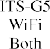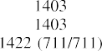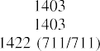

when compared with the traditional WiFi. These results also show that the average delay per chunk is 17.87 ms for the ITS-G5 scenario and 58.09 ms for the WiFi scenario. If both technologies are used simultaneously (3 MB of file per radio access technology), the transmission delay is marked by the slower one, i.e., the WiFi. In this case the WiFi is able to dis- patch half of the file in 14 s (transmitting 711 chunks) and the ITS-G5 requires 42 s to transmit the other half of the file (using the same amount chunks). This experience, whose details are presented in [35], shows the potential of the ATCLL in designing and experimenting new solutions for different communication paradigms, such as the NDN.

1. *Use Case 7: Safe Urban Mobility*

Improving road safety can be a challenging task for city managers and authorities. On the one side, smart cities provide new opportunities to monitor road safety and alert authorities when something unexpected happens. On the other side, track- ing every part of the city can be an expensive task. However, by integrating the sensing data, collected by the ATCLL, with information provided by citizens using social media, such as Twitter, we can have near real-time information about traffic incidents.

In this use case, we show how data from radars and cameras can be used to monitor traffic metrics (e.g., the amount of light and heavy vehicles, their speed, the amount of people, etc.) and provide alerts when unexpected events are detected, such as unexpected traffic congestion. Data collected from radars and vehicular messages (CAMs) in the ATCLL is used along with the object detection service (Section VI-A), detecting people crossing outside the crosswalk. A machine learning model is used to capture information provided by citizens about acci- dents, traffic congestion, and other incidents in the Twitter platform, which is then used along with the ATCLL platform to publish alerts and provide real-time analysis.

Integrating social media information allows a broader range of people to contribute with relevant traffic information. Besides, we can alert more people through social media, since most people do not use Google Maps or Waze in their daily lives but rather when traveling to an unknown place.

1. RESEARCH CHALLENGES AND FUTURE DIRECTIONS

Building a living lab is not an easy task, especially when it scales to the full size of a city. From all the challenges related with the development of a living lab, the size is for sure the one that matters the most. Small-scale living labs limited to a laboratory, to a building or even to a university campus are becoming more common. Their deployment, management, and

even financial tasks are *easy* when compared to a city-scale testbed, mainly because the number of entities that need to be involved is quite reduced. During the deployment of the ATCLL, the research team had to constantly interact with the Municipality of Aveiro and the University of Aveiro (both part- ners in the European project Aveiro STEAM City), but also with other third parties entities, such as Transdev, responsi- ble for the Aveiro public buses where some of the OBUs are placed, and the energy provider company to find solutions to grant electricity to our Smart Lamp Posts, to name a few.

Another challenge faced during the deployment of the ATCLL was the selection of the equipment to equip the living lab. Many of the smart cities around the world, as discussed in Section II, were built to sense the city, designed to col- lect information from it, such as the mobility of its citizens or environmental data, and turning them available for visual- ization and posterior analyzes by third-party actors, e.g., the municipalities. The ATCLL is not a *simple* data collecting infrastructure as it provides the possibility for experimentation, in search for new technological products, not only application- related but also targeting the communication, computation, and data aggregation layers. Thus, the selection of off-the- shelf equipment was reduced and addressing mainly the data acquisition tasks, such as cameras, radars, and LiDARs, while the communication and computation devices were selected to allow a certain level of configuration and/or modification, such as SDN/P4 switches and open-hardware SBCs used in the RSUs and OBUs. Although we have shown the different use cases independently, this platform supports network pro- grammability through SDN and P4, and services automated deployment through micro services and Kubernetes. The sup- port of different services in different nodes can be personalized through a dynamic allocation and orchestration of the services. Security and privacy are also challenging topics when deploying a living lab, especially when it is open for experi- mentation. In the security plane, our major concern was related with the authentication and authorization to the ATCLL infras- tructure. Experimenters receive temporary and secure access to predefined resources with limited functionalities, i.e., the min- imum required to run the experiment. In addition, and because the living lab is also supporting legacy applications, such as data acquisition from the several sensors placed in the city, we assure that the running experiments will not disrupt those services. This is implemented by the means of different vir- tual local area networks (VLANs) or through the SDN and P4 features, allowing for the dynamic support and simultaneously run of isolated networks and flows in the same infrastructure. In the privacy plane, and in order to guarantee that we comply with the general data protection regulation (GDPR) require- ments, the data acquired by the sensors is processed locally in the edge, protecting the user’s privacy, transmitting only metadata to the core, such as the number of people walking on a crosswalk or the number of vehicles in a road segment. Data poisoning and inference attacks should also be a subject of concern in such large-scale living labs as the data generated by the several sensors may be manipulated by nonlegitimate users [45]. Privacy-preserving frameworks exploring machine

learning techniques, such as the ones in [46] and [47], could be used to ensure IoT privacy and security.

The transition from a smart to a responsive city is also underway in the ATCLL. As a living ecosystem, cities could be seen as cyber–physical “systems of systems,” and repre- sented by a digital twin (DT). The ATCLL is a DT, a virtual representation of the city as a virtual world, supporting a set of different use cases, which includes: urban planning; cir- cular economy; traffic, mobility, and fleet management; and environment monitoring. Compared with current DT deploy- ments [48], the ATCLL represents one of the most complete DTs. The volume of data collected by the city sensors could be used to provide deeper insights into each system operation. For instance, the data collected by the vehicular network and the mobility sensors in real time are already used to create a virtual replica of the city traffic. This allows to predict in real-time the effect of changes in the city traffic, and evaluate risk man- agement scenarios, replacing conventional simulations. Waste management is also represented in our DT, by the vehicu- lar network. In a near future, new optimized collection routes could be used to optimize this city vertical.

Energy is one of the most important topics in city-level management. The increase of electric vehicles (EVs) in the city leads to different consumption patterns in the grid. Our mobility data could help to improve urban planning and grid optimization. The use of advanced AI-embedded systems, as the ones presented in Section VI, are also helping in the development of specific federated models, for each vertical, allowing to keep data isolated for privacy and data-governance reasons. Models from different cities could also be shared to the ATCLL. In [49], an urban traffic flow prediction model was designed, in the city of Porto, and is now being applied in the ATCLL. One of the reasons for such easy integration is the use of already available standards in the DT domain (e.g., NGSI-LD), capable of modeling the context data and context information of the city.

1. CONCLUSION

The large majority of existing contributions related to con- nectivity in different scenarios, including mobile scenarios with people, bicycles, and vehicles still rely on numerical computations and computer simulations, not addressing the impairments of real environments.

In this article we present a living lab platform that allows the support of research activities in a real environment with real users, making them a beneficial part of the research. ATCLL is a facility deployed as a city-scale testbed with a large number of IoT devices, with communication, sensing, and computing capabilities, built on fiber and mmWave links, integrating a communication network with radio terminals, multiprotocol, spread throughout the city. The ATCLL supports a wide range of services and applications: IoT, ITSs, and assisted driving, environmental monitoring, emergency and safety, and more.

The data of the platform is gathered through edge com- puting and a datacenter where the services, data platform, apps, 5G core and network functions are deployed in vir- tual machines running in the cloud. The presented results

demonstrate a dashboard with visibility of real-time data and examples of data collected (traffic radar, camera, and WiFi sniffing). Performance results were also plotted, demonstrat- ing the coverage of the communication technologies, the usage of edge computing and the implementation of the SDN-based vehicular network. Finally, several use cases were tested in the infrastructure, in particular mobility characterization, collision avoidance with VRUs, emergency vehicles communication, a data platform for IIoT to cloud continuum, mmWave backhaul research, and an ICN deployment.

ACKNOWLEDGMENT

The authors would like to thank André Mourato and Tomás Freitas for the involvement in the development of the mobility services; Ricardo Torres and João Milheiro for the deployment of the spectral probes and SDR units; Alexandre Figueiredo and Tânia Ferreira for the research activities described in use case 5; and Luis Gameiro and Gustavo Amaral for the experiments described in use case 6.

REFERENCES

1. C. Harrison et al., “Foundations for smarter cities,” *IBM J. Res. Develop.*, vol. 54, no. 4, pp. 1–16, Jul./Aug. 2010.
2. C. Veeckman, D. Schuurman, S. Leminen, and M. Westerlund, “Linking living lab characteristics and their outcomes: Towards a conceptual framework,” *Technol. Innov. Manag. Rev.*, vol. 3, pp. 6–15, Dec. 2013.
3. T. Ojala, “Open urban testbed for ubiquitous computing,” in *Proc. Int.* *Conf. Commun. Mobile Comput.*, vol. 1, 2010, pp. 442–447.
4. L. Sanchez et al., “SmartSantander: IoT experimentation over a smart city testbed,” *Comput. Netw.*, vol. 61, pp. 217–238, Mar. 2014.
5. J. Lanza et al., “Large-scale mobile sensing enabled Internet-of-Things testbed for smart city services,” *Int. J. Distrib. Sens. Netw.*, vol. 11, no. 8, 2015, Art. no. 785061, doi: [10.1155/2015/785061](http://dx.doi.org/10.1155/2015/785061).
6. R. Hu, “The state of smart cities in China: The case of Shenzhen,”

*Energies*, vol. 12, no. 22, p. 4375, 2019.

1. V. Sankaran and A. Chopra, “Creating global sustainable smart cities (a case study of Masdar City),” in *Proc. J. Phys. Conf. Ser.*, Dec. 2020, Art. no. 12141.
2. T. Yigitcanlar, H. Han, M. Kamruzzaman, G. Ioppolo, and

J. Sabatini-Marques, “The making of smart cities: Are Songdo, Masdar, Amsterdam, San Francisco and Brisbane the best we could build?” *Land* *Use Policy*, vol. 88, Nov. 2019, Art. no. 104187.

1. M. Bauer, L. Sanchez, and J. Song, “IoT-enabled smart cities: Evolution and outlook,” *Sensors*, vol. 21, p. 4511, Jul. 2021.
2. S. Latre, P. Leroux, T. Coenen, B. Braem, P. Ballon, and P. Demeester, “City of things: An integrated and multi-technology testbed for IoT smart city experiments,” in *Proc. IEEE Int. Smart Cities Conf. (ISC2)*, 2016, pp. 1–8.
3. V. M. Larios, L. Gomez, O. B. Mora, R. Maciel, and

N. Villanueva-Rosales, “Living labs for smart cities: A use case in Guadalajara city to foster innovation and develop citizen-centered solutions,” in *Proc. IEEE Int. Smart Cities Conf. (ISC2)*, 2016, pp. 1–6.

1. I. Negreiros et al., “Smart campus as a living lab on sustainability indicators monitoring,” in *Proc. IEEE Int. Smart Cities Conf. (ISC2)*, 2020, pp. 1–5.
2. B. Braem, S. Latre, P. Leroux, P. Demeester, T. Coenen, and P. Ballon, “Designing a smart city playground: Real-time air quality measurements and visualization in the city of things testbed,” in *Proc. IEEE Int. Smart* *Cities Conf. (ISC2)*, 2016, pp. 1–2.
3. C. Ameixieira et al., “HarborNet: A real-world testbed for vehicular networks,” *IEEE Commun. Mag.*, vol. 52, no. 9, pp. 108–114, Sep. 2014.
4. P. Sotres, J. Lanza, L. Sánchez, J. R. Santana, C. López, and L. Muñoz, “Breaking vendors and city locks through a semantic-enabled global interoperable Internet-of-Things system: A smart parking case,” *Sensors*, vol. 19, p. 229, Jan. 2019.
5. M. Gascó-Hernandez, “Building a smart city: Lessons from Barcelona,”

*Commun. ACM*, vol. 61, no. 4, pp. 50–57, 2018.

1. P. M. Santos et al., “PortoLivingLab: An IoT-based sensing platform for smart cities,” *IEEE Internet Things J.*, vol. 5, no. 2, pp. 523–532, Apr. 2018.
2. J. Ferreira et al., “PASMO: An open living lab for cooperative ITS and smart regions,” in *Proc. Int. Smart Cities Conf. (ISC2)*, 2017, pp. 1–6.
3. J. Marquez-Barja et al., “Smart highway: ITS-G5 and C2VX based testbed for vehicular communications in real environments enhanced by edge/cloud technologies,” in *Proc. Eur. Conf. Netw. Commun. (EuCNC)*, 2019, p. 2.
4. V. Charpentier, N. Slamnik-Krijestorac, and J. Marquez-Barja, “Latency- aware C-ITS application for improving the road safety with CAM messages on the smart highway testbed,” in *Proc. IEEE INFOCOM Conf. Comput. Commun. Workshops (INFOCOM WKSHPS)*, 2022, pp. 1–6.
5. C. Antonelli et al., “The city of L’Aquila as a living lab: The INCIPICT project and the 5G trial,” in *Proc. IEEE 5G World Forum (5GWF)*, 2018, pp. 410–415.
6. I. Zajc, R. Sernec, G. Lenart, and A. Pucihar, “Autonomous mobility and user perception: A case of city as a lab in Slovenia,” in *Proc. 43rd Int.* *Conv. Inf. Commun. Electron. Technol. (MIPRO)*, 2020, pp. 1843–1847.
7. Z. Kostic´ et al., “Smart city intersections: Intelligence nodes for future metropolises,” *Computer*, vol. 55, no. 12, pp. 74–85, Dec. 2022.
8. D. Amaxilatis et al., “Advancing experimentation-as-a-service through urban IoT experiments,” *IEEE Internet Things J.*, vol. 6, no. 2, pp. 2563–2572, Apr. 2019.
9. V. Gutiérrez, D. Amaxilatis, G. Mylonas, and L. Muñoz, “Empowering citizens toward the co-creation of sustainable cities,” *IEEE Internet* *Things J.*, vol. 5, no. 2, pp. 668–676, Apr. 2018.
10. D. Kreutz, F. M. V. Ramos, P. E. Veríssimo, C. E. Rothenberg,

S. Azodolmolky, and S. Uhlig, “Software-defined networking: A com- prehensive survey,” *Proc. IEEE*, vol. 103, no. 1, pp. 14–76, Jan. 2015.

1. M. Silva, P. Teixeira, C. Gomes, D. Dias, M. Luís, and S. Sargento, “Exploring software defined networks for seamless handovers in vehic- ular networks,” *Veh. Commun.*, vol. 31, Oct. 2021, Art. no. 100372.
2. G. Vítor, P. Rito, and S. Sargento, “Smart city data platform for real-time processing and data sharing,” in *Proc. IEEE Symp. Comput. Commun.* *(ISCC)*, 2021, pp. 1–7.
3. A. Voronov, Zeverin, and D. Heuven, *Geonetworking: Vehicle Adapter* *(Version V1.0.0)*, Zenodo, Meyrin, Switzerland, May 2016.
4. J. Mendes, F. Neves, R. Matos, and S. Sargento, “Prediction-based con- nection manager for vehicular networks,” in *Proc. IEEE Symp. Comput.* *Commun. (ISCC)*, 2015, pp. 353–358.
5. “OpenFlow switch specification.” Accessed: Nov. 2021. [Online]. Available: https://opennetworking.org/wp-content/uploads/2014/10/ openflow-switch-v1.5.1.pdf
6. A. Djama, B. Djamaa, and M. R. Senouci, “Information-centric networking solutions for the Internet of Things: A systematic mapping review,” *Comput. Commun.*, vol. 159, pp. 37–59, Jun. 2020.
7. D. Hernandez, L. Gameiro, C. Senna, M. Luís, and S. Sargento, “Handling producer and consumer mobility in IoT publish–subscribe named data networks,” *IEEE Internet Things J.*, vol. 9, no. 2, pp. 868–884, Jan. 2022.
8. S. Mastorakis, A. Afanasyev, and L. Zhang, “On the evolution of ndnSIM: An open-source simulator for NDN experimentation,” *SIGCOMM Comput. Commun. Rev.*, vol. 47, no. 3, pp. 19–33, Sep. 2017.
9. L. Gameiro, C. Senna, and M. Luís, “Insights from the experimenta- tion of named data networks in mobile wireless environments,” *Future* *Internet*, vol. 14, no. 7, p. 196, 2022.
10. A. Figueiredo, P. Rito, M. Luís, and S. Sargento, “Mobility sensing and V2X communication for emergency services,” *Mobile Netw. Appl.*, to be published.
11. G. Perna, R. Rosmaninho, H. Sampaio, P. Rito, M. Luís, and S. Sargento, “On the performance of 5G for cloud- and edge-based emergency services in smart cities,” in *Proc. 12th Int. Conf. Netw. Future (NoF)*, 2021, pp. 1–5.
12. P. Teixeira, S. Sargento, P. Rito, M. Luís, and F. Castro, “A sensing, com- munication and computing approach for vulnerable road users safety,” *IEEE Access*, vol. 11, pp. 4914–4930, 2023.
13. *Intelligent Transport Systems (ITS); V2X Applications V1.1.1 (2018-06)*, ETSI Standard TS 101 539-2, 2018.
14. Y. Seol, D. Hyeon, J. Min, M. Kim, and J. Paek, “Timely survey of time- sensitive networking: Past and future directions,” *IEEE Access*, vol. 9, pp. 142506–142527, 2021.
15. F. H. Cabrini et al., “Enabling the industrial Internet of Things to cloud continuum in a real city environment,” *Sensors*, vol. 21, no. 22, p. 7707, 2021.
16. A. Figueiredo, T. Ferreira, D. Raposo, M. Luís, P. Rito, and S. Sargento, “On the real experimentation and simulation models for millimeter- wave,” *IEEE Access*, vol. 10, pp. 51191–51208, 2022.
17. E. Dias et al., “Ultra-reliable low-latency millimeter-wave communica- tions with sliding window network coding,” 2022, *arXiv:2205.00793*.
18. C. Filsfils, S. Previdi, L. Ginsberg, B. Decraene, S. Litkowski, and R. Shakir, “Segment routing architecture,” IETF, RFC 8402, Jul. 2018.
19. E. Ismagilova, L. Hughes, N. P. Rana, and Y. K. Dwivedi, “Security, privacy and risks within smart cities: Literature review and development of a smart city interaction framework,” *Inf. Syst. Front.*, vol. 24, no. 2, pp. 393–414, 2022.
20. P. Kumar et al., “PPSF: A privacy-preserving and secure frame- work using blockchain-based machine-learning for IoT-driven smart cities,” *IEEE Trans. Netw. Sci. Eng.*, vol. 8, no. 3, pp. 2326–2341, Jul.–Sep. 2021.
21. G. Li, J. Wu, S. Li, W. Yang, and C. Li, “Multitentacle federated learning over software-defined industrial Internet of Things against adap- tive poisoning attacks,” *IEEE Trans. Ind. Informat.*, vol. 19, no. 2, pp. 1260–1269, Feb. 2023.
22. G. Mylonas, A. Kalogeras, G. Kalogeras, C. Anagnostopoulos,

C. Alexakos, and L. Muñoz, “Digital twins from smart manufacturing to smart cities: A survey,” *IEEE Access*, vol. 9, pp. 143222–143249, 2021.

1. A. Almeida, S. Brás, I. Oliveira, and S. Sargento, “Vehicular traffic flow prediction using deployed traffic counters in a city,” *Future Gener. Comput. Syst.*, vol. 128, pp. 429–442, Mar. 2022.